**House Price Analysis Project**

Robert Blue, Louis Garcia

# Introduction

Home buying is one of the most stressful and important financial decisions people can go through. Adding in factors like choosing location, which school district is the best, or safety of the neighborhood only makes it even more complicated. Luckily for you, we have built out an algorithm that can help reduce this stress on families and get you in the home of your dreams.

# Data Description

We will be using the [Ames Housing dataset](https://www.amstat.org/publications/jse/v19n3/decock.pdf), which was compiled by Dean De Cock, that pulled 79 explanatory variables that we will then use to train our model to do the prediction for you. This particular data set explores just about every aspect of residential homes located in Ames, Iowa and includes everything from size of the garage (if there is one) to type of masonry used in the fireplace. Using this multitude of variables, we will select which ones that have the highest impact on sales price.

We have a training data set that contains 1460 observations (homes) and a test set that does not include sales price with another 1460 homes to test our algorithm against. In our study, we will tackle two analysis questions. The first is focused solely on three specific neighborhoods, North Ames, Edwards, and Brookside and only on the square footage of the general living area vs the sales price. The second analysis will include all 28 neighborhoods and any relevant factor that will play into sales price.

# Analysis Question 1:

## Problem We Want To Solve

Our team was commissioned by Century 21 Ames from Ames, Iowa to do a study on the relationship between the square footage of the living area in a house and the sale price. Since Century 21 Ames only operates out of the North Ames, Edwards, and Brookside neighborhoods, we will only be focusing on those three neighborhoods for this question. As we understand from our initial meeting, there are members of Century 21 Ames management that have a statistical background, but we will make this analysis understandable to anyone who might not have as strong a background.

## Build and Fit the Model

The first step in analysis is cleaning up your data. In this case, we created a new set called houseTrain where we only included the three neighborhoods that Century 21 Ames operates in. Once we narrowed down our dataset to just those three areas, the next big step is to plot the data so we can build the assumptions (Plot 1.1 and Plot 1.2).

First, we can build an initial model:

$μ_{SalePrice}= β_{0}+ β_{1}* GrLIvArea$

### Checking Assumptions

The scatter plot in Plot 1.1 shows there is evidence of a linear relationship between GrLIvArea and SalesPrice (the two variables we were asked to analyze); however, we can see there are several outliers that are skewing our data. This is even more apparent in our residual plot (Plot 1.3) where the variance of the points has decent clustering at the lower points in the x-axis, but as we increase x (in this case, general living area), the variance begins to deviate significantly from the mean. This can be seen yet again in our initial fit model (Plot 1.4).

Let’s now take a deeper dive into our Fit Diagnostics for our initial model (Plot 1.2). From our Studentized vs Leverage plots, we can see clear outliers that have heavily skewed our initial fit. This can be made even more clear from our Cook’s D plot that shows a Cook’s D value of more than 5. Finally, our studentized residual vs predicted value plot shows several points that are more than 土2.5 standard deviations away from our mean. What all of this analysis means is that we have a handful of points that are so outside of our average range (aka, outliers) that they are directly affecting how our prediction line is drawn. Typically, you want to have points that are within 土2.5 from your mean as well as having your residuals, which are just the distance each point is from the mean line, to all group relatively around our mean line (Plot 1.3 has good clustering, but that breaks as we increase our GrLIvArea).

Our Histogram in Plot 1.3 shows that we can assume normality while the Q-Q Plot does have some concerning points towards the higher X and Y values.

We can proceed with the assumption that sales price and general living area are independent from one another.

Once we take out the outliers (as seen in Tables 1.2 and 1.3), we can re-fit our model to show that our residual plots and Cook’s D is much more manageable (Plots 1.5, 1.6, 1.7). Cook’s D values are less than or equal to 0.10 with the newly cleaned data as well as an improved adjusted R-Squared of 0.449.

$μ_{SalePrice}= β_{0}+ β_{1}(GrLIvArea) +β_{2}(BrkSide) + β_{3}(Edwards) +β_{5}(GrLIvArea)(BrkSide)$ $+β_{6}(GrLIvArea)(Edwards)$

### Parameters

We can see that all interactions (Table 1.5) and variables play a significant role in determining the price. We know this by looking at our p-value (Pr > |t| in the table) and the fact that all p-values are less than our alpha of 0.05. What this means in more simple terms is that the probability of observing a value that is greater than the observed test value from this particular sample is lower than 5%. Another good bit of information from this table is we can begin to estimate what our sales price will be in relation to our variables. If you recall from above, our full fitted regression model to predict sale price is:

$μ_{SalePrice}= β_{0}+ β_{1}(GrLIvArea) +β_{2}(BrkSide) + β_{3}(Edwards)+β_{5}(GrLIvArea)(BrkSide)$ $+β_{6}(GrLIvArea)(Edwards)$

We can separate our main regression model into three models for each neighborhood using North Ames as our reference.

**For NAmes (reference)**

μ{SalePrice|NAmes} = 80325.71 + 49.56(GrLIvArea) - 60354.20(0) - 43225.29(0) + 37.60(GrLIvArea)(0) + 20.60 (GrLIvArea)(0)

**μ{SalePrice|NAmes} = 80325.71 + 49.56(GrLIvArea)**

**For BrkSide:**

μ{SalePrice|BrkSide} = 80325.71 + 49.56(GrLIvArea) - 60354.20(1) - 43225.29(0) + 37.60(GrLIvArea)(1) + 20.60 (GrLIvArea)(0)

μ{SalePrice|BrkSide} = 80325.71 + 49.56(GrLIvArea) - 60354.20 - 37.60(GrLIvArea)

**μ{SalePrice|BrkSide} = 19971.51 + 87.16(GrLIvArea)**

**For Edwards:**

μ{SalePrice|Edwards} = 80325.71 + 49.56(GrLIvArea) - 60354.20(0) - 43225.29(1) + 37.60(GrLIvArea)(0) + 20.60 (GrLIvArea)(1)

μ{SalePrice|Edwards} = 80325.71 + 49.56(GrLIvArea) - 43225.29 + 20.60 (GrLIvArea)(1)

**μ{SalePrice|Edwards} = 37100.42 + 70.16(GrLIvArea)**

### Interpretation

Our model is a 95% confident fit and is an estimated prediction. That being said, we can interpret each model as follows:

For the North Ames neighborhood, for every 100 square foot of living area increase, it is estimated with 95% certainty that the sale price on average will increase between $4,150 and $5,762. The best guessed estimate is a $4,956 increase.

For the Brookside neighborhood, for every 100 square foot of living area increase, it is estimated that the sale price on average will increase between $1,911 and $5,609 compared to homes in North Ames. Our best estimate is an increase of $3,760

For the Edwards neighborhood, for every 100 square foot of living area increase, it is estimated that the sale price on average will increase between $446 and $3,672 compared to homes in North Ames. Our best estimate is an increase of $2,059

## Conclusion

There is significant evidence that our model fits all three neighborhoods (p-value of <0.0001 using linear regression). Since this was only an observational study, we can’t make any causal inferences to the population of Ames, or even the three neighborhoods being studied, as a whole. With that being said, there is strong evidence of a relationship between increasing sale price and increasing square-footage of the living area. There is also strong evidence that the Brookside neighborhood is associated with higher sale price, followed by Edwards, and finally North Ames.

## R Shiny: Price v. Living Area Chart

<https://rblue101.shinyapps.io/HousingPrice/>

# **Analysis Question 2:**

## **Problem We Want To Solve**

Our team was tasked to build the most predictive model for sales prices of homes in all of Ames Iowa. We will be building models that predict sale price for houses and measure their accuracy by how low the residuals of the logged sale price is.

## **Build and Fit the Model**

### **Type of Selection**

There are many assumptions that need to be met and we must also perform residual analysis so that our models increase their likelihood of being more accurate. We wanted to test how impactful this process is and so there were two waves of selections that occurred, one where we analyzed the residuals, meeting assumptions, and one where we ran variable selection without fixing issues.

The [Resolve issues with numeric outliers and delete variables with high VIF] section in Appendix covers the two waves of removing outliers with high Cook’sD and large RStudent+Leverage. The continuous variables had 81 NAs removed, other NAs replaced with their respective variables medians, 3 observations removed after the first round of outlier remediation and 8 observations removed in the second round. From this we then picked out the variables that looked to have a linear relationship with SalePrice and then commenced to use the variable selection models and deal with outliers.

The continuous variables that the variable selection models gave us and met the linear association assumptions were *LotFrontage LotArea TotalBsmtSF GrLivArea GarageArea.*

(Table 2.8-2.13 were experimentation and just there for viewer’s enjoyment)

**Stepwise**

The Stepwise model with no issues fixed and using all variables and interactions (Table 2.3) had a CVPRESS of 1.428639E12.

The Stepwise model done after NA analysis and influential point analysis for numeric variables using all variables and interactions (Table 2.17) had a CVPRESS of 5.220454E11

Using the linearly related continuous variables, *LotFrontage LotArea TotalBsmtSF GrLivArea GarageArea,* and all categorical variables, stepwise variable selection was conducted. The model at the end was SalePrice = BsmtFinType1+BsmtQual*CentralAir+LotArea*SaleCondition+TotalBsmtSF*KitchenQual+ GrLivArea*Neighborhood+GrLivArea*BldgType+GrLivArea*Functional+GarageArea*BsmtExposureBsmtFinType1 BsmtQual*CentralAir

LotArea*SaleCondition TotalBsmtSF*KitchenQual GrLivArea*Neighborhood GrLivArea*BldgType GrLivArea*Functional GarageArea*BsmtExposure.

From here we conducted two rounds of influential point analysis and got rid of observations that had high RStudent values and leverage, the CVPRESS ended up being 3.87808E11 (Stepwise Table 2.2)

**Forward**

The forward model with no issues fixed and using all variables and interactions (Table 2.2) had a CVPRESS of 8.673746E11.

The forward model done after NA analysis and influential point analysis for numeric variables using all variables and interactions (Table 2.18) had a CVPRESS of 5.198503E11.

Using the linearly related continuous variables, *LotFrontage LotArea TotalBsmtSF GrLivArea GarageArea,* and all categorical variables, forward variable selection was conducted. The model at the end was SalePrice = BsmtFinType1+BsmtQual*CentralAir+LotArea*GarageQual+LotArea*SaleCondition+ TotalBsmtSF*KitchenQual+GrLivArea*Neighborhood+GrLivArea*BldgType+GrLivArea*Functional+GarageArea*ExterQual+GarageArea*BsmtExposure+GarageArea*GarageFinish

From here we conducted two rounds of influential point analysis and got rid of observations that had high RStudent values and leverage, the CVPRESS ended up being 3.471234E11 (Forward Table 2.1)

**Backward**

Due to memory constraints, SAS could not perform backwards variable selection with all variables and interactions.

Given that it wouldn’t be able to deal with all categorical variables, the backwards selection model is made up of purely continuous variables. High values of RStudent were removed and there were no observations concerning Cook’sD values [**Start doing variable selection for the models](Tables and plots that start with ‘Back’ in the [[Backwards variable selection]] subsection ){back table 2.1, back plot 2.1, etc}.** The model ended up being SalePrice = LotFrontage + LotArea + TotalBsmtSF + GrLivArea + GarageArea.

**Custom**

Performed forward,backward, and stepwise variable selection using only the categorical variables to see which variables got the lowest CVPRESS (Table 2.14-2.16)

Performed forward,backward, and stepwise variable selection using only the numeric variables to see which variables got the lowest CVPRESS (Table 2.5-2.7).

Wanted to see how good SL models are and so we performed forward,backward, and stepwise variable selection using the categorical variables that got the lowest CVPRESS (Table 2.21) and the numeric variables that got the lowest CVPRESS(Table 2.7). The model that we submitted was using variables from the backwards variable selection one as it had a RMSE of 0 and Adjusted R2 of 1 but CVPRESS of 1.182087E34 once we switched over to CV as the stop instead of SL.

### **Checking Assumptions**

**Residual Plots**

(Back Plot 2.2) shows how each numeric variable that was used in forwards, backwards, and stepwise variable selection (*LotFrontage LotArea TotalBsmtSF GrLivArea GarageArea.)* has equal standard deviation of residuals

(Back Plot 2.4) shows the residual plot for the backwards variable selection model

(Forward Plot 2.2) shows the residual plot for the forward variable selection model

(Stepwise Plot 2.2) shows the residual plot for the stepwise variable selection model

**Influential point analysis (Cook’s D and Leverage)**

Removing influential observations that had influence just makes other observations have influence instead and so they were only remediated twice at most.

From Plot 2.5 to Plot 2.10 there was remediation of the regression model that included all numeric variables in the dataset so that the RStudent and Cook’sD plots didn’t have drastic outliers. This was done so the VIF would not be misleading.

(Back Plot 2.4) showed Cook’sD of .15, this was removed from the datasets and (Back Plot 2.5) shows that the influential points were taken care of.

Influential points for forward selection shown in (Forward Plot 2.1), these were remediated twice and (Forward Plot 2.2) shows what they look like after the remediation

Influential points for stepwise selection shown in (Stepwise Plot 2.1), these were remediated twice and (Stepwise Plot 2.2) shows what they look like after the remediation

**Make sure to address each assumption**

Plot 2.16 shows our continuous variables meeting the assumption of linear relationship with response.

Plot 2.17 shows that the variables that had a linear relationship did not have high VIFs.

### **Comparing Competing Model**

| **Predictive Models** | **Adjusted R2** | **CV PRESS** | **Kaggle Score\** |
| --- | --- | --- | --- |
| Forward | .9319 | 3.359214E11 | ..32974 |
| Backward | .8231 | 1.317704E12 | ..23366 |
| Stepwise | .9244 | 3.87808E11 | ..33457 |
| CUSTOM | 0.9932 | 1.182087E34 | 8.17367 |

## **Conclusion**

Even though the backwards variable selection had the worst CVPRESS and lowest Adjusted R2, it got the best Kaggle score and therefore was our best model. The cleaning of the data really helps models perform well as seen from how every model with clean data did better than the ones that were not clean. Lastly, even though the custom model seemed good on paper since when the variables were derived the RMSE was 0 and the Adjusted R2 was 1, it overfit way too much and got the worse Kaggle score and the corresponding CVPRESS was the largest.

Appendix

# ANALYSIS 1

Pull in the data for both the training and test sets  
  
Training Set

| proc import datafile='/home/u62089780/DS6731/train.csv'  out= train  DBMS=csv replace; run; |
| --- |

Test Set

| proc import datafile='/home/u62089780/DS6731/test.csv'  out=test  DBMS=csv replace; run; |
| --- |

Sanity Check to see if the data was loaded in

| proc print data = train; run; |
| --- |

Create training set with only the three neighborhoods being analized

| data houseTrain; set train; where neighborhood = 'NAmes' OR  neighborhood = 'BrkSide' OR  neighborhood = 'Edwards'; run; |
| --- |

Plot out the Sales Price in relation to General Living Area

| title 'Scatter Plot of Sales Prices vs Living Area SQFT'; proc sgplot data = houseTrain; scatter x = GrLIvArea y = SalePrice; run; |
| --- |

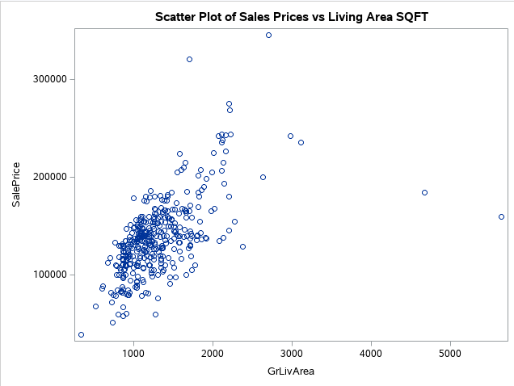

Plot 1.1

Create the initial regression model with SalePrice = y and GrLIvArea = x

| proc reg data = houseTrain; model SalePrice = GrLIvArea / vif cli; run; |
| --- |

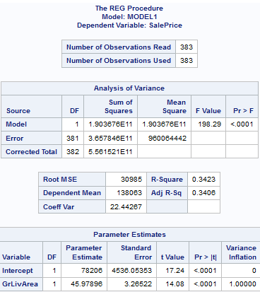

Table 1.1

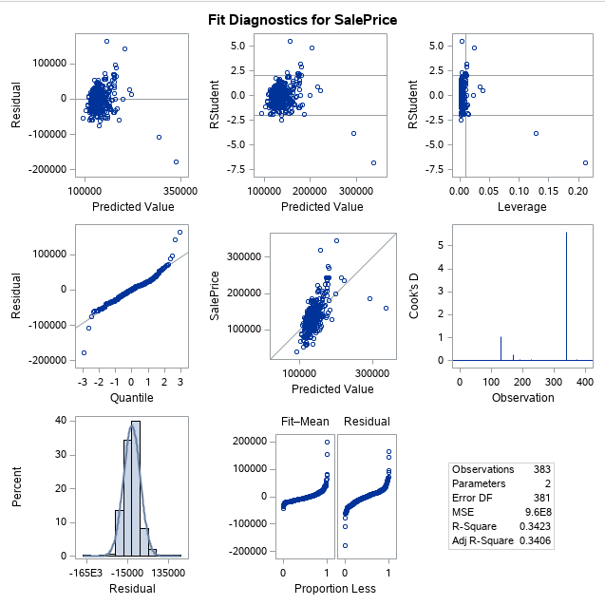

Plot 1.2

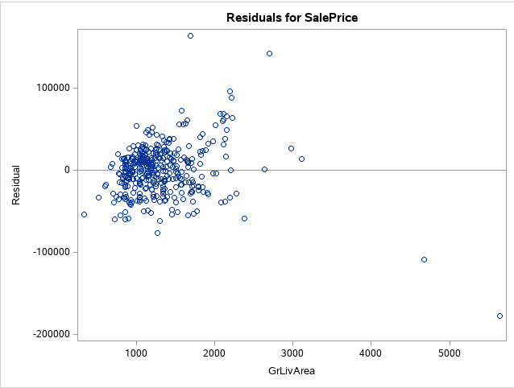

Plot 1.3

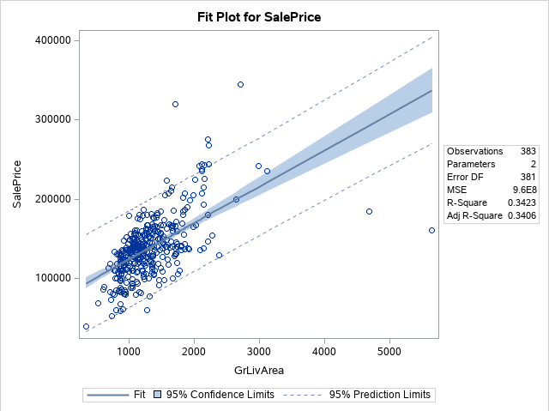

Plot 1.4

This snippet of code helps to find the extreme ouliers in SalePrice that are affecting the regression model

| proc univariate data=houseTrain robustscale plot; var SalePrice; run; |
| --- |

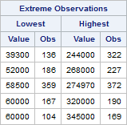

Table 1.2

This snippet of code helps to find the extreme outliers in GrLIvArea that are affecting the regression model

| proc univariate data=houseTrain robustscale plot; var GrLIvArea; run; |
| --- |

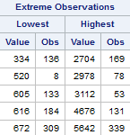

Table 1.3

The code recognized four outliers and we will proceed to remove them.

| data houseTrainOutliers; set houseTrain; where Id = 643 or Id = 725 or Id = 1299 or Id = 524; run; |
| --- |

Printing out the outliers with their values

| proc print data = houseTrainOutliers; var Id; var GrLIvArea; var SalePrice; run; |
| --- |

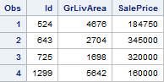

Table 1.4

Creating a new dataset without the outliers

| data houseTrainClean; set houseTrain; if Id = 643 or Id = 725 or Id = 1299 or Id = 524 then delete; run; |
| --- |

Running a new regression model with the clean dataset

| proc reg data = houseTrainClean; model SalePrice = GrLIvArea / vif cli; run; |
| --- |

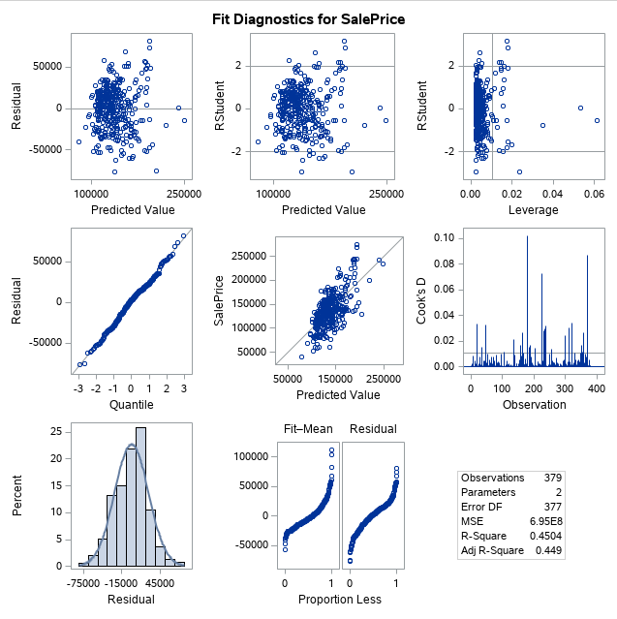

Plot 1.5

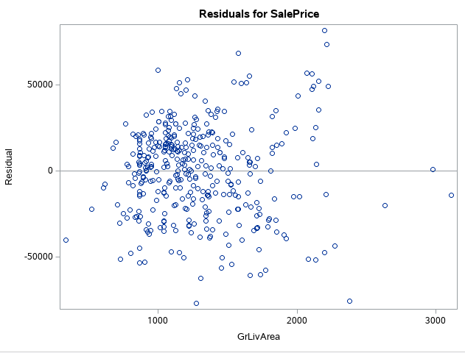

Plot 1.6

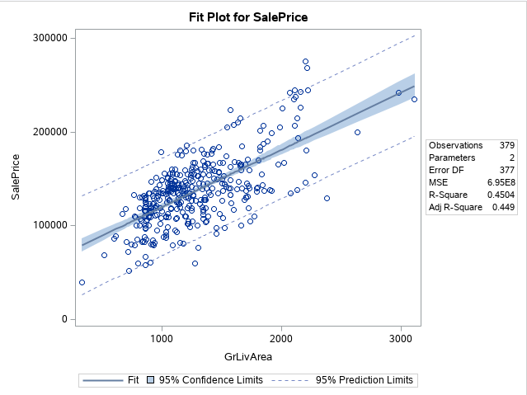

Plot 1.7

Building a model with the Neighborhood variable as an explanatory variable

| proc glm data = houseTrainClean plots = all; class Neighborhood; model SalePrice = GrLIvArea | Neighborhood / solution clparm cli; run; |
| --- |

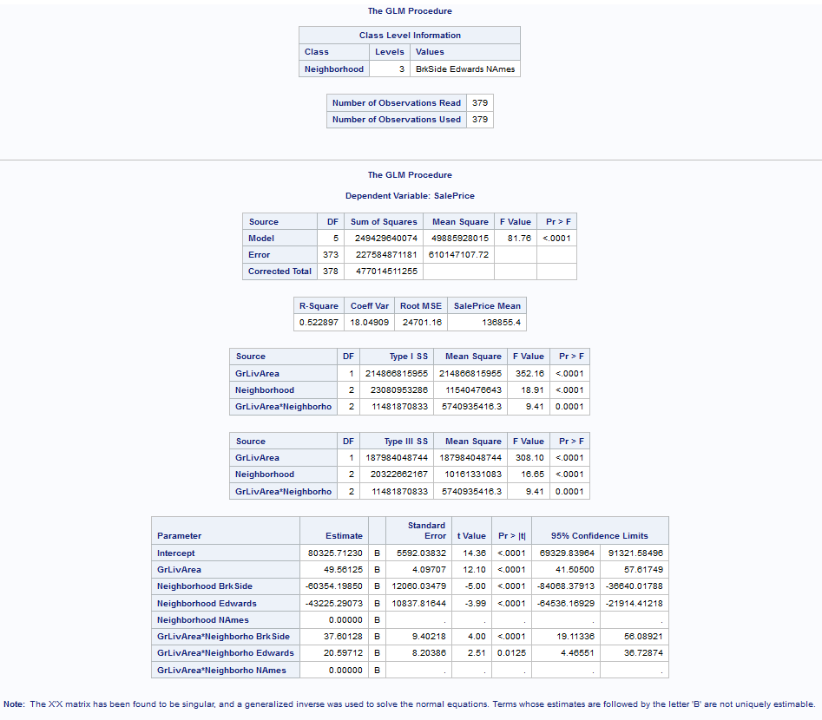

Table 1.5

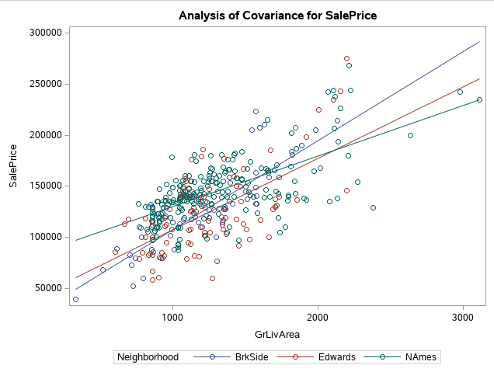

Plot 1.8

# ANALYSIS 2

**Pull in data for train set, disregarding the changes made to dataset in Analysis 1**

LotFrontage was made a character because NA was read as a string, fixed this (Table 2.1)

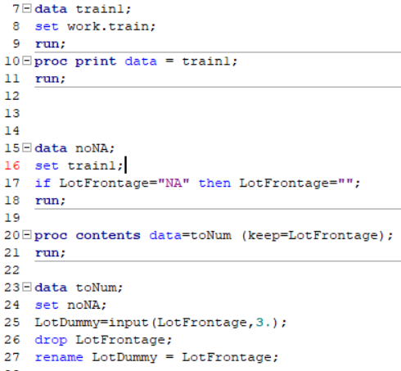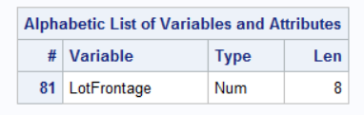

**Doing Variable Selection with data right off bat to see how CVPRESS differs**

Tying Forward Selection without cleaning data (Table 2.2)

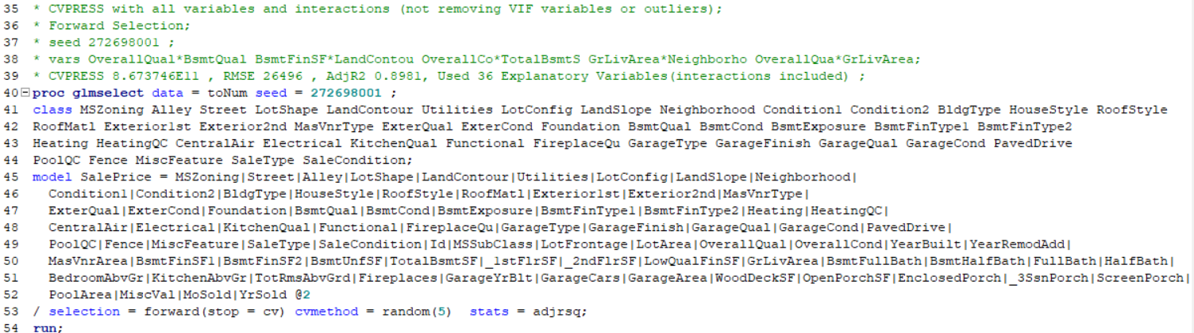

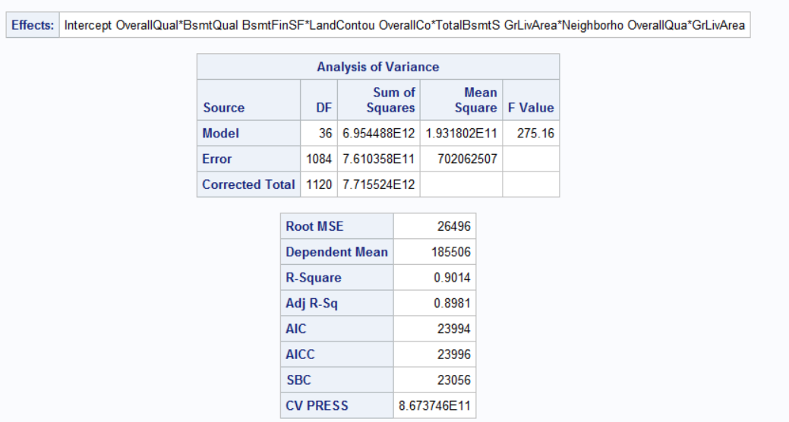

Tying StepWise Selection without cleaning data (Table 2.3)

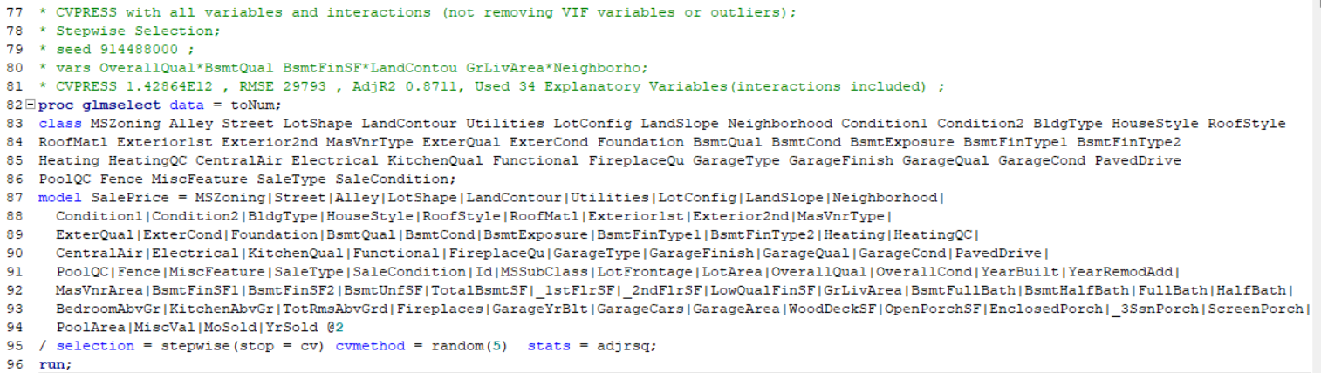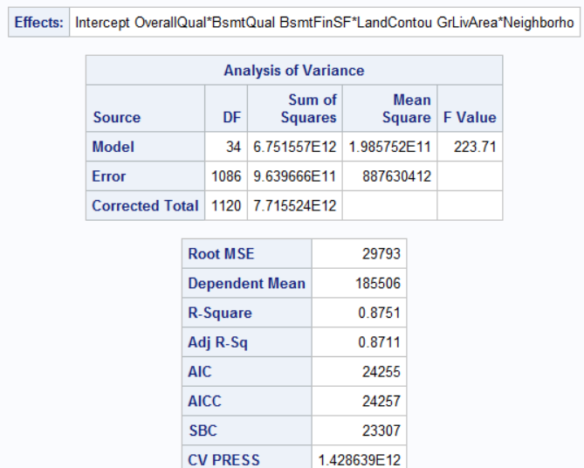

## Not enough memory to perform BackWard selection

**Checking to see what a model with all the numeric variables looks like**

## Still not cleaning data, plots and outliers worried me (Plot 2.1)

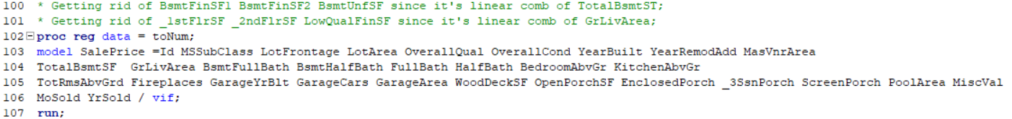

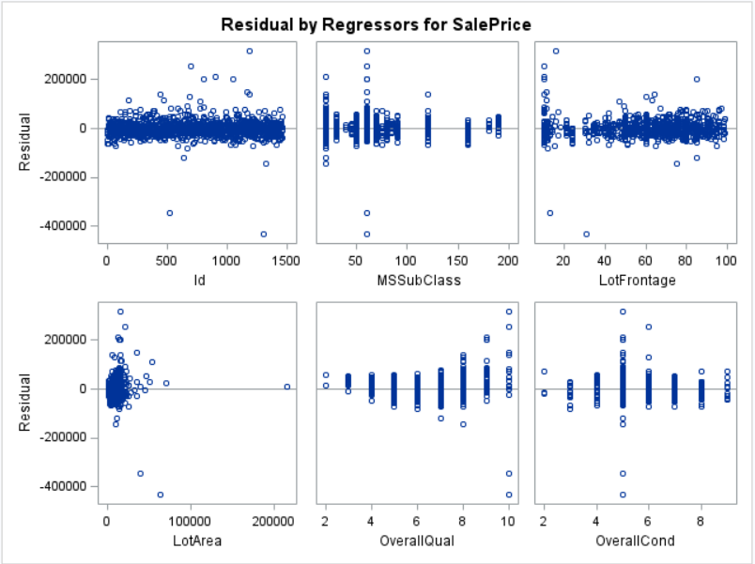

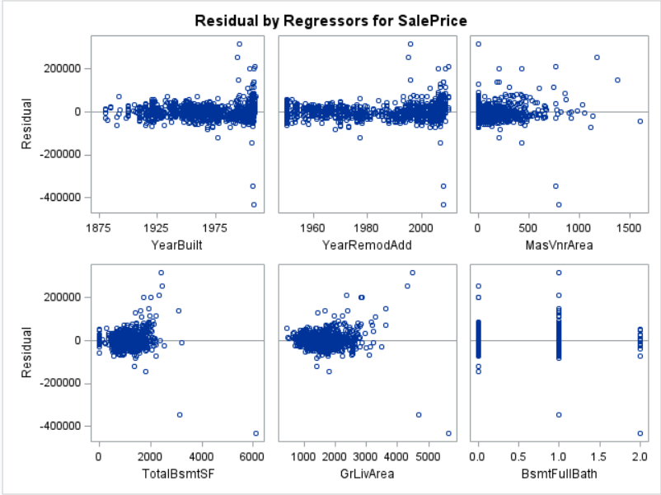

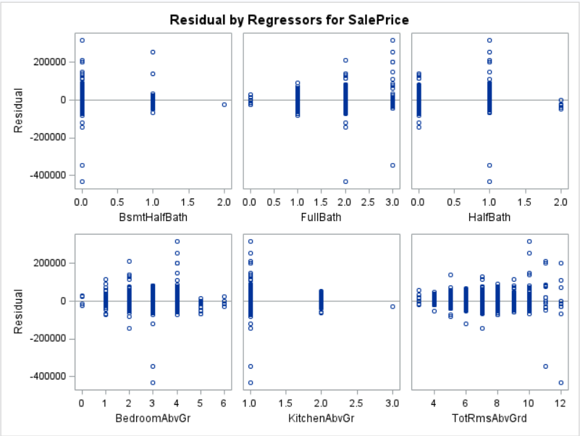

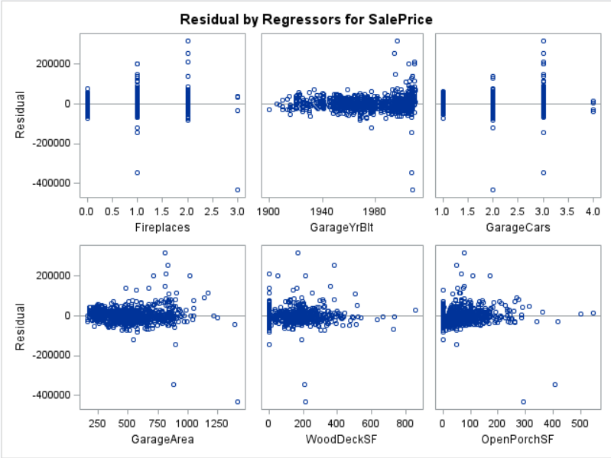

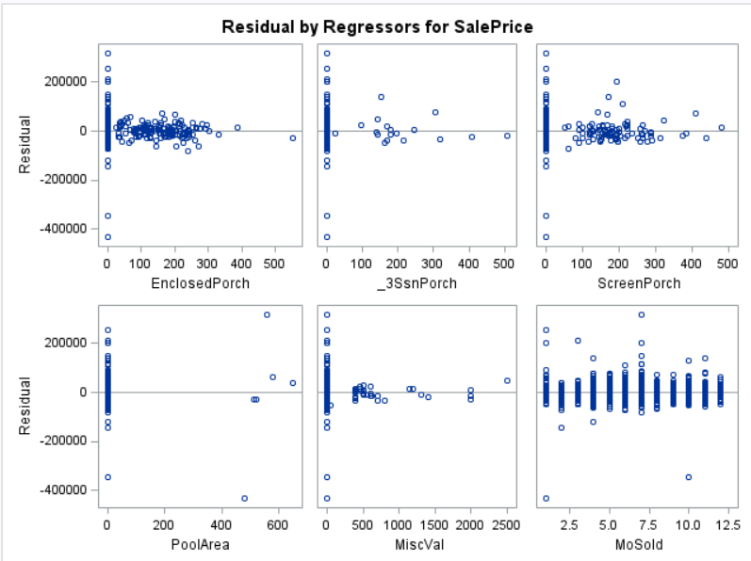

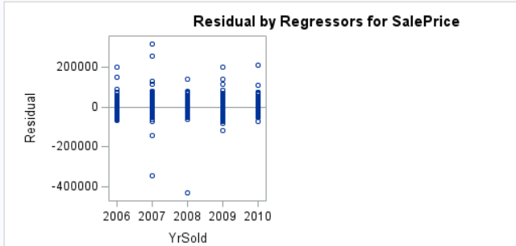

## Numeric residual plots (2.2)

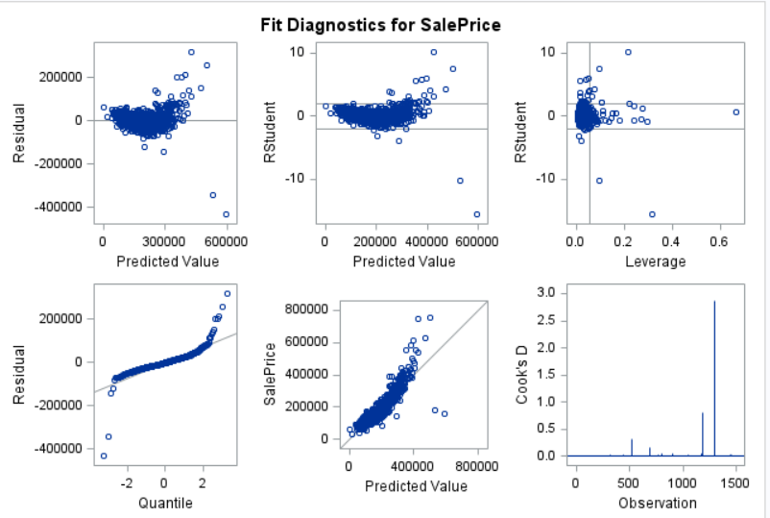

## Number of observations dropped (Table 2.4)

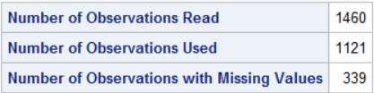

**Clean Numeric Variables in R**

## Read data into R, print numbers of NAs per numeric variable, and identify variables with NAs

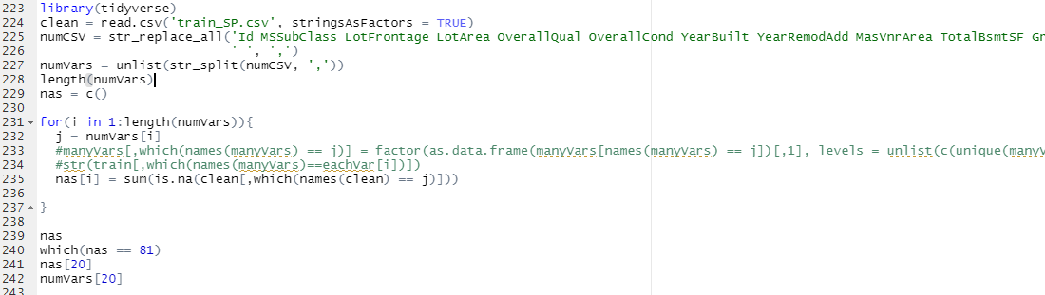

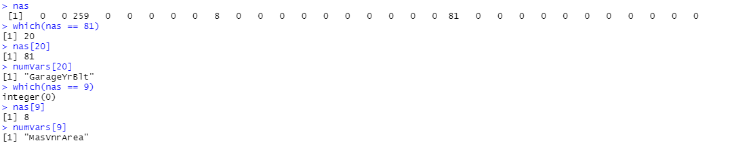

## Plot LotFrontage histogram (Plot 2.3)



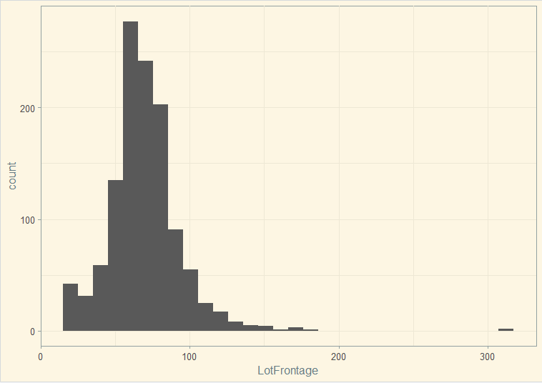

## Replace LotFrontage NAs with its median



## Replace MasVrnArea NAs with zero

## Plot GarageYrBlt histogram (Plot 2.4)



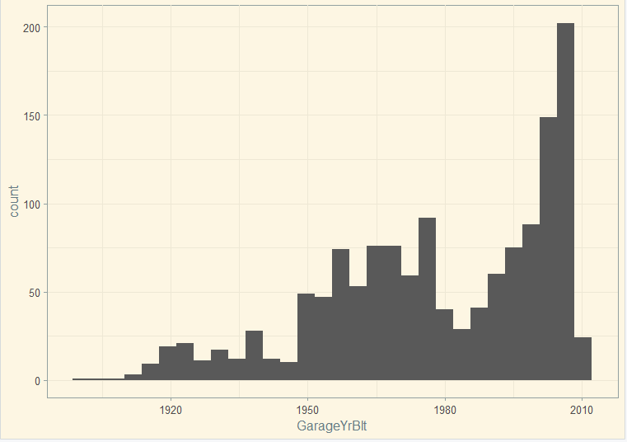

## Drop GarageYrBlt NAs and export a new dataset with cleaned numeric variables



## Make MSSubClass a factor and add ‘Class’ in front of the numbers it has, export dataset

**Resolve issues with numeric outliers and delete variables with high VIF**

## Import clean data into SAS and find variables with outliers (Plot 2.5)

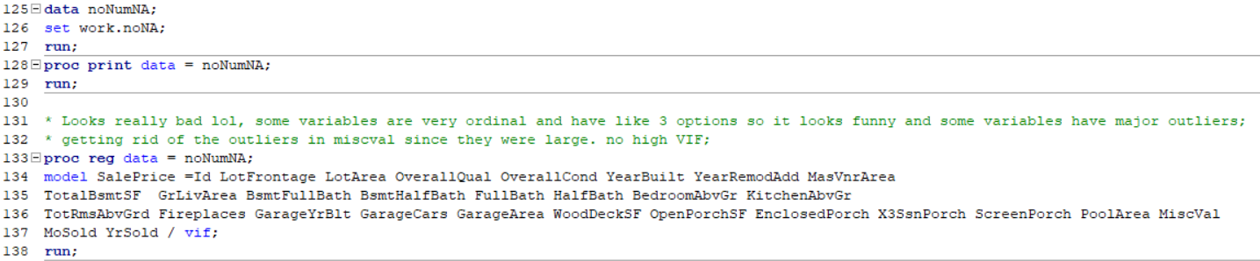

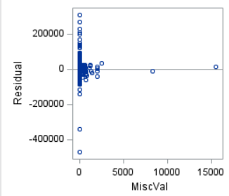

## Identify which entries for MiscVal are the outliers and remove them

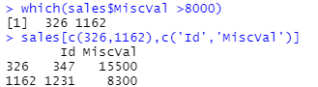

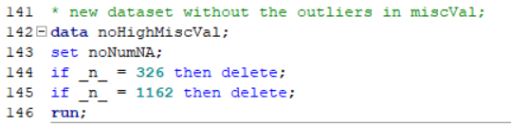

## Re-run plot the residual plots and identify high VIF and look at residual plots (Plot 2.6)

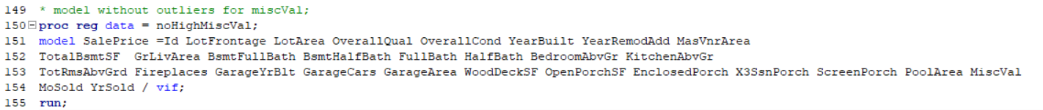

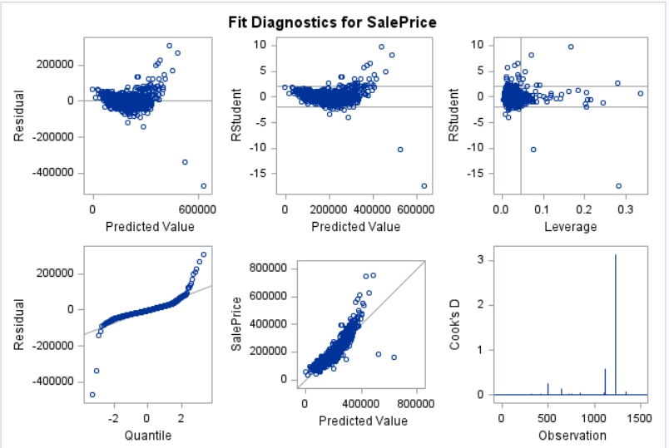



## Identify TotalBsmtSF as variable that may be causing high CooksD and delete the entry (Plot 2.7)

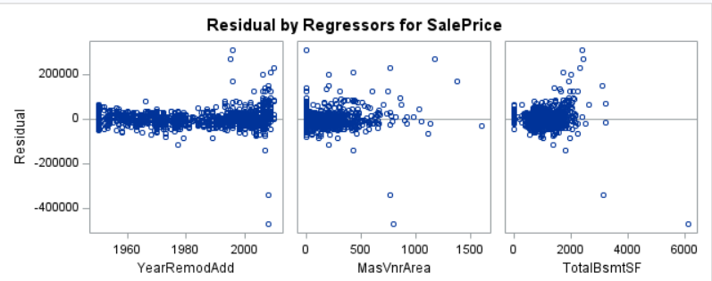

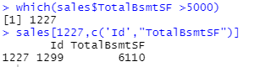

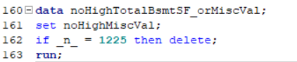

## Re-run residual plots without MiscVal and TotalBsmtSF outliers to check CooksD and Rstudent (Plot 2.8)

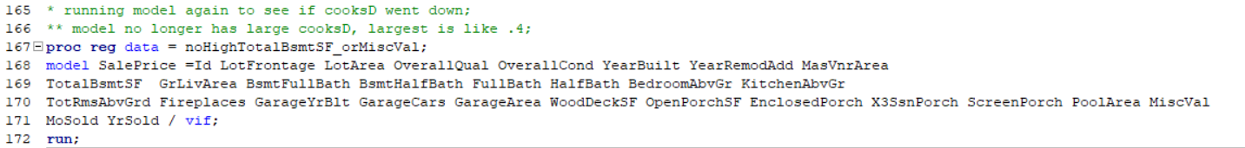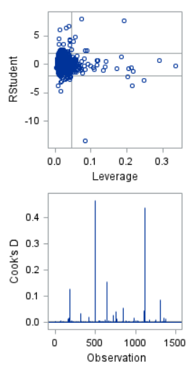

## Create dataset in R without the 3 numeric variable outliers and get Rstudent per entry

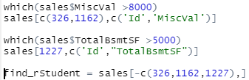

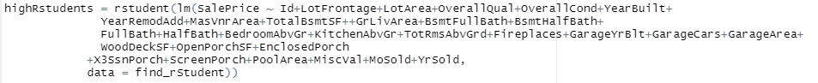

## Identify and remove entries with Rstudent higher than absolute value of 5, make new dataset

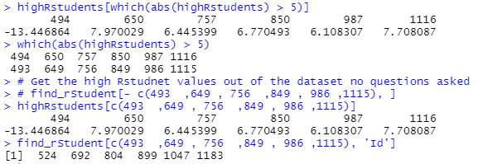

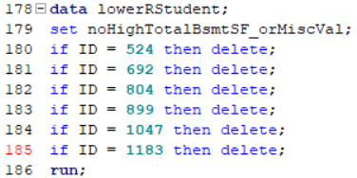

## Plot RStudent without values larger than |5| after 1st remediation (Plot 2.9)

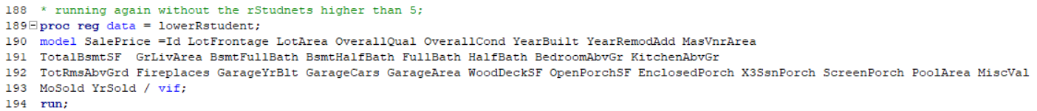

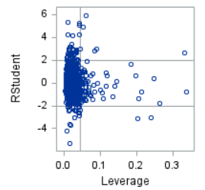

## Identify and remove entries with Rstudent higher than 4 and to right of .05 Leverage, make new dataset

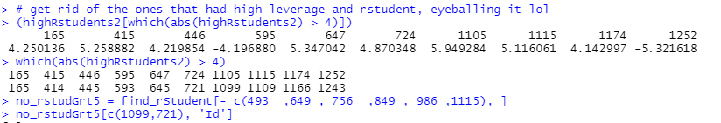

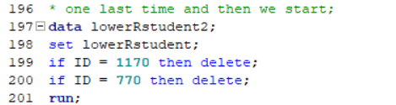

## Plot residual plots without entries that had Rstudent higher than 4 and to right of .05 Leverage (Plot 2.10)



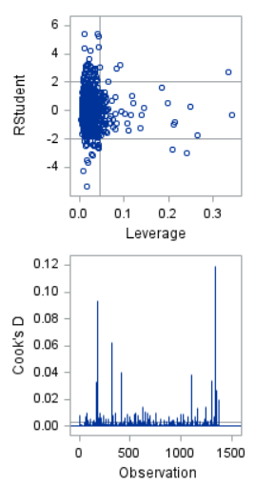

**Do Variable Selection for numeric variables now that data is clean without drastic outliers**

## StepWise Selection model for cleaned numeric variables (Table 2.5)

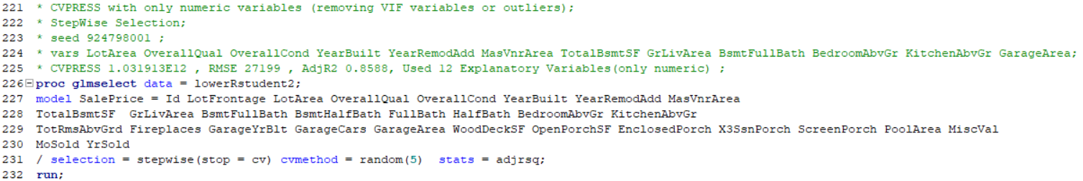

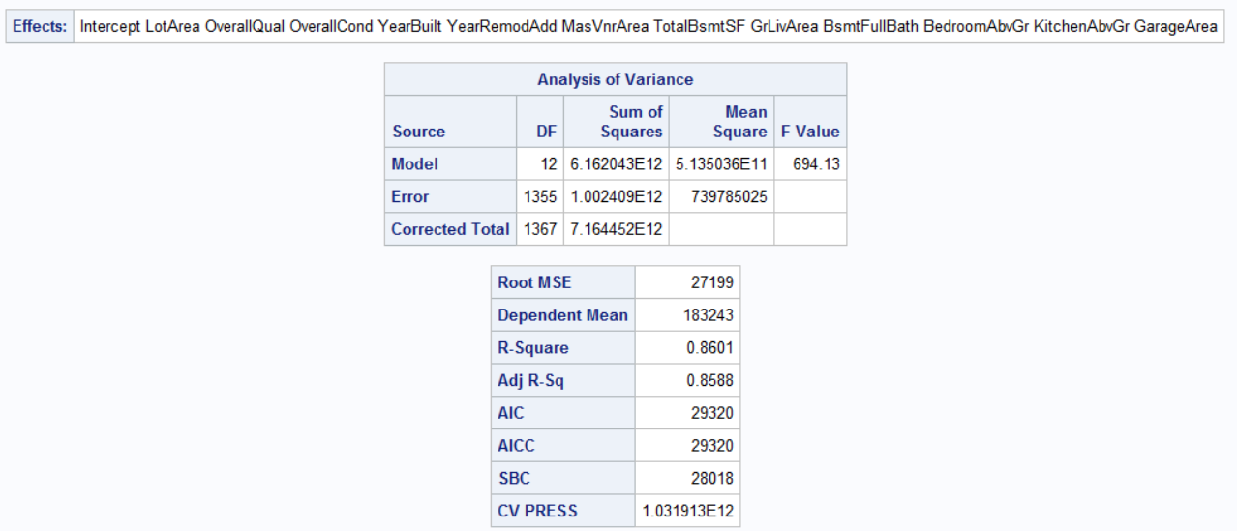

## Forward Selection model for cleaned numeric variables (Table 2.6)

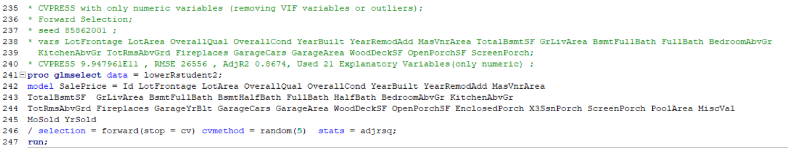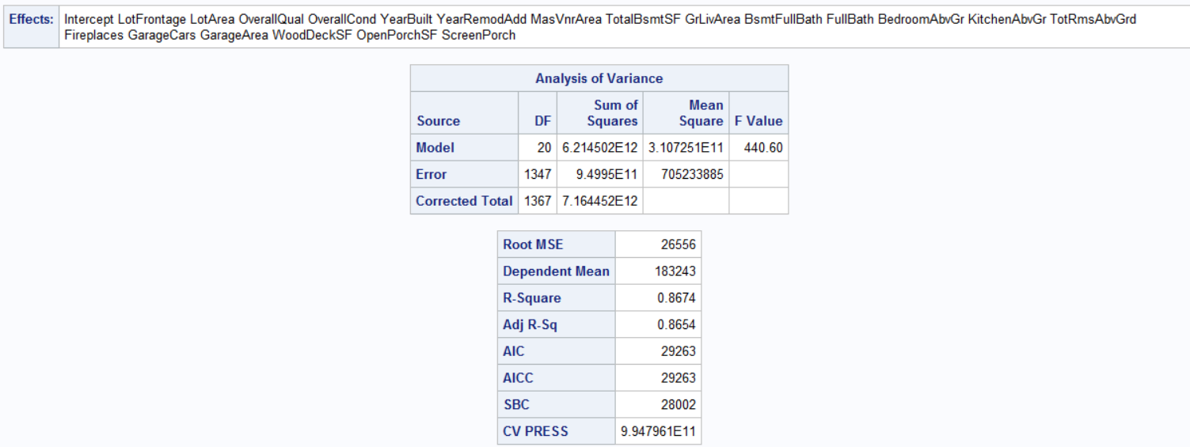

## Backward Selection model for cleaned numeric variables (Table 2.7)

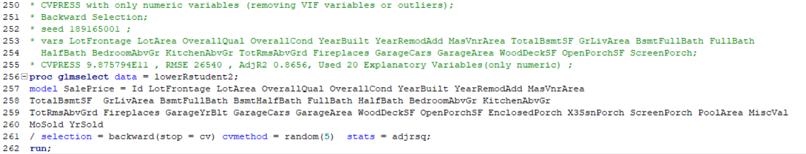

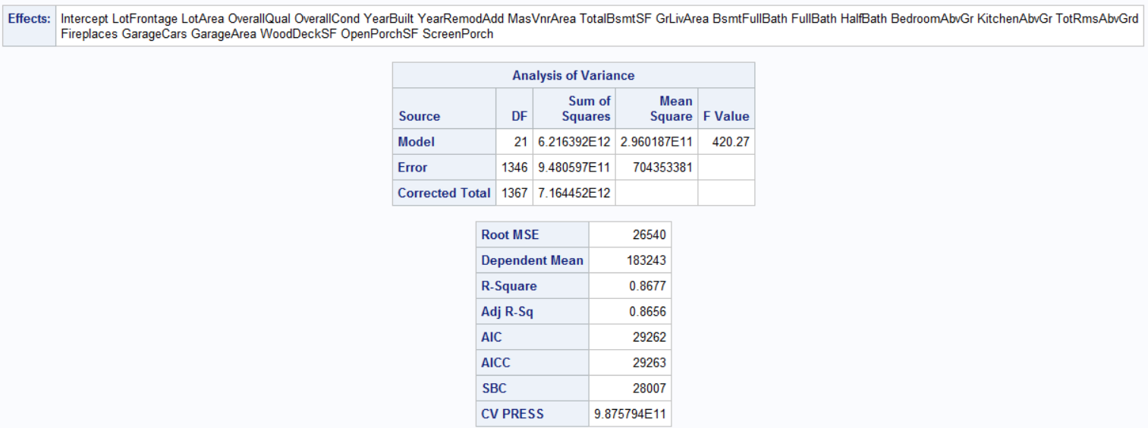

**Clean Categorical Variables in R**

## Use dataset without numeric outlier problems and identify if variables that use the string NA as an entry which means ‘None’ have NAs because of this

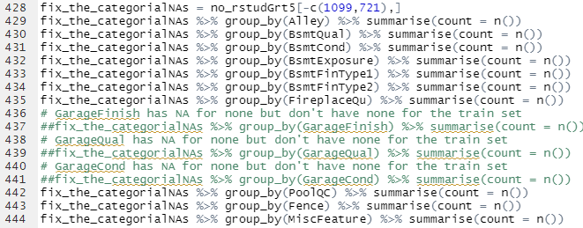

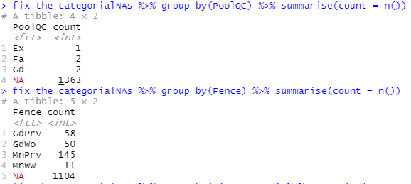

## Relabel the NAs with what NA was supposed to represent, check it this fixed levels

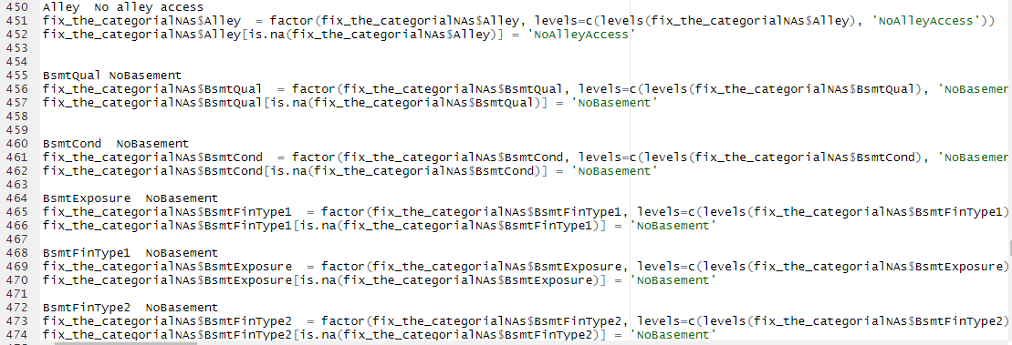

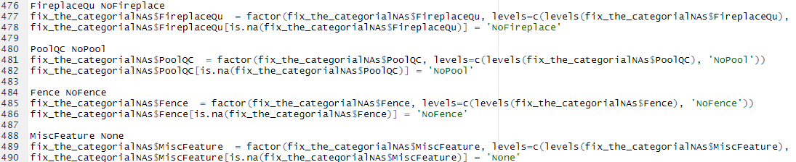2.17

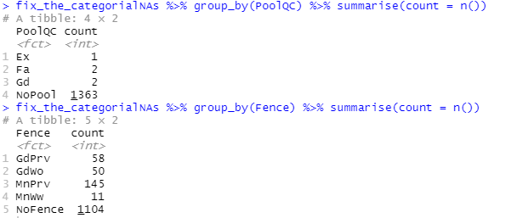

## Export a new dataset with cleaned categorical variables, import into SAS





**Do Variable Selection for cleaned numeric and categorical variables with interactions. Use numeric variables derived from StepWise selection**

## Stepwise model using numeric variables derived from stepwise variable selection (Table 2.8)

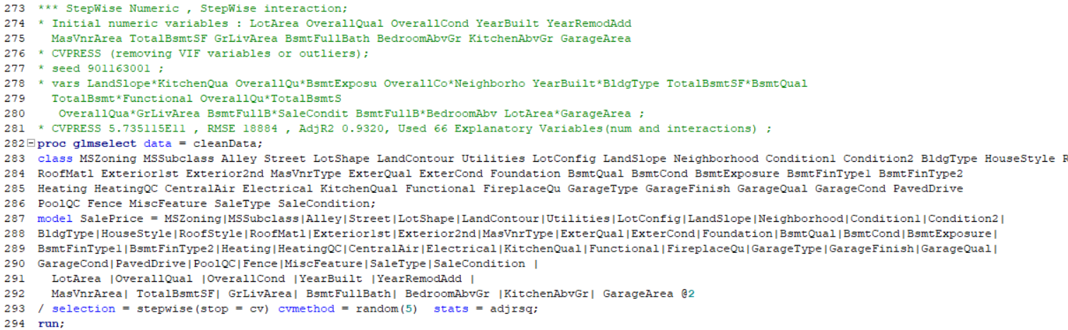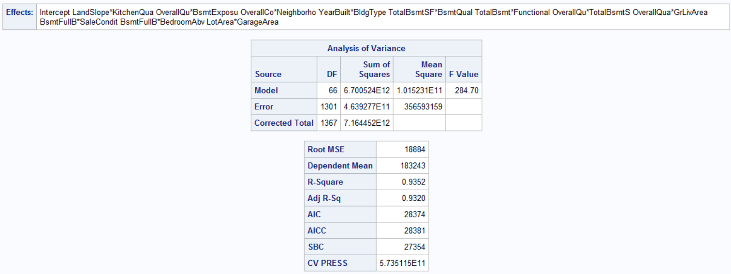

## Forward model using numeric variables derived from stepwise variable selection (2.9)

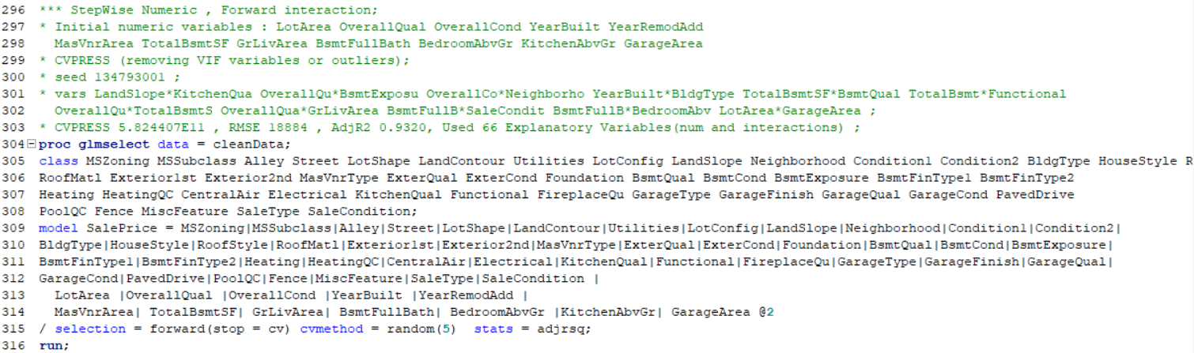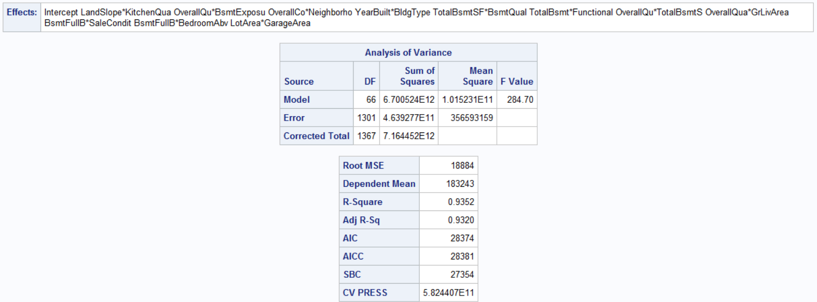

## Backward model using numeric variables derived from stepwise variable selection could not run because of lack of memory

**Do Variable Selection for cleaned numeric and categorical variables with interactions. Use numeric variables derived from Forward selection**

## Stepwise model using numeric variables derived from forward variable selection (Table 2.10)

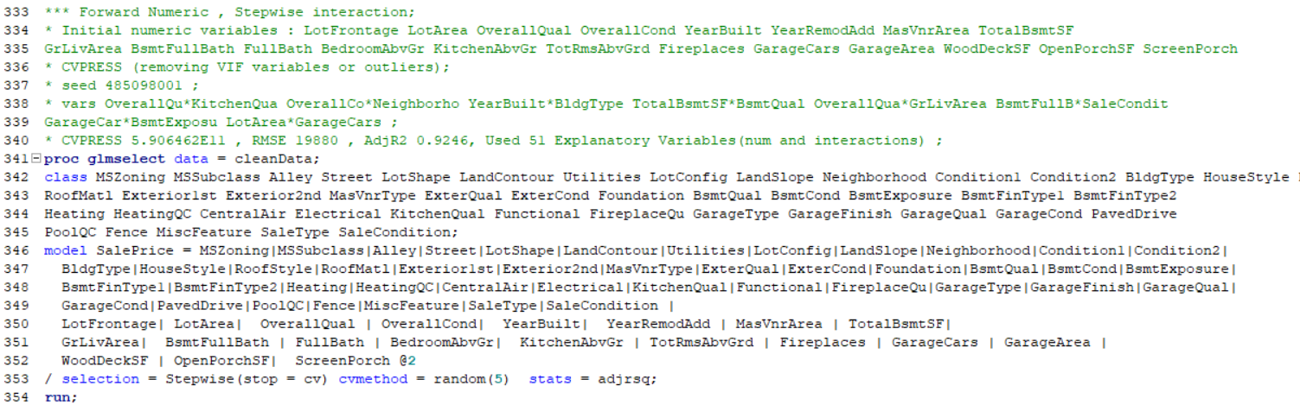

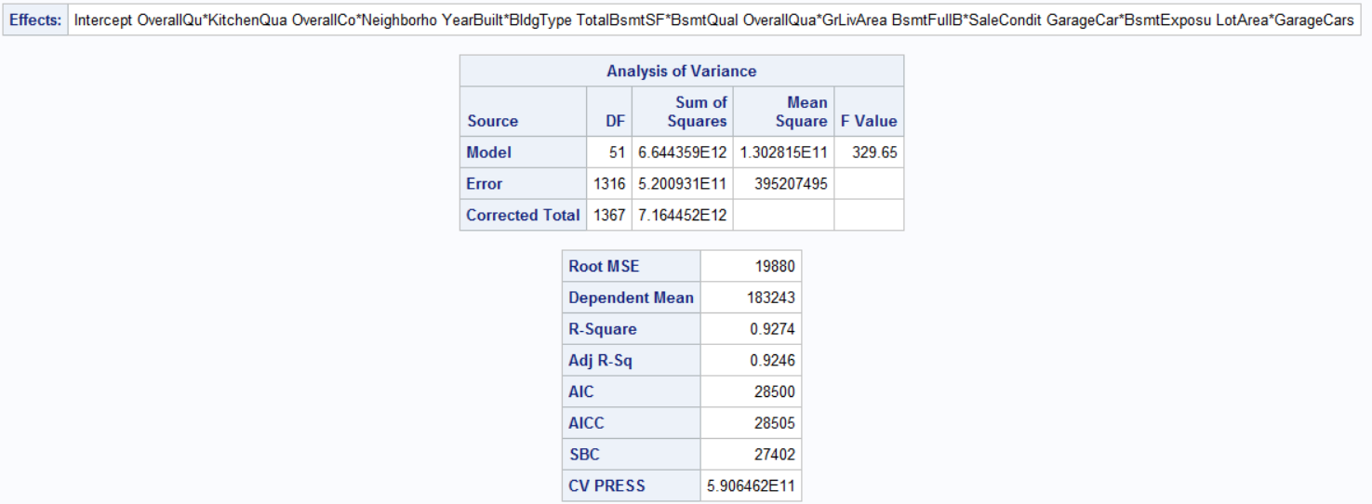

## Stepwise model using numeric variables derived from forward variable selection (Table 2.11)

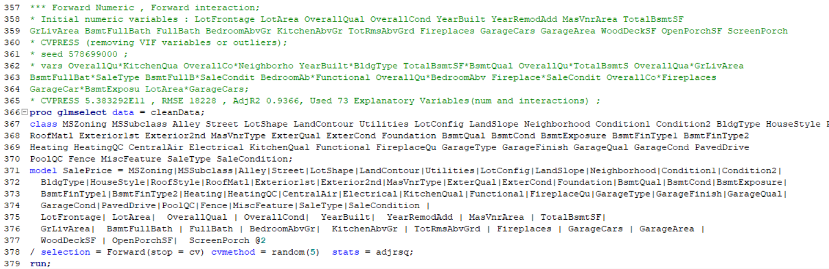

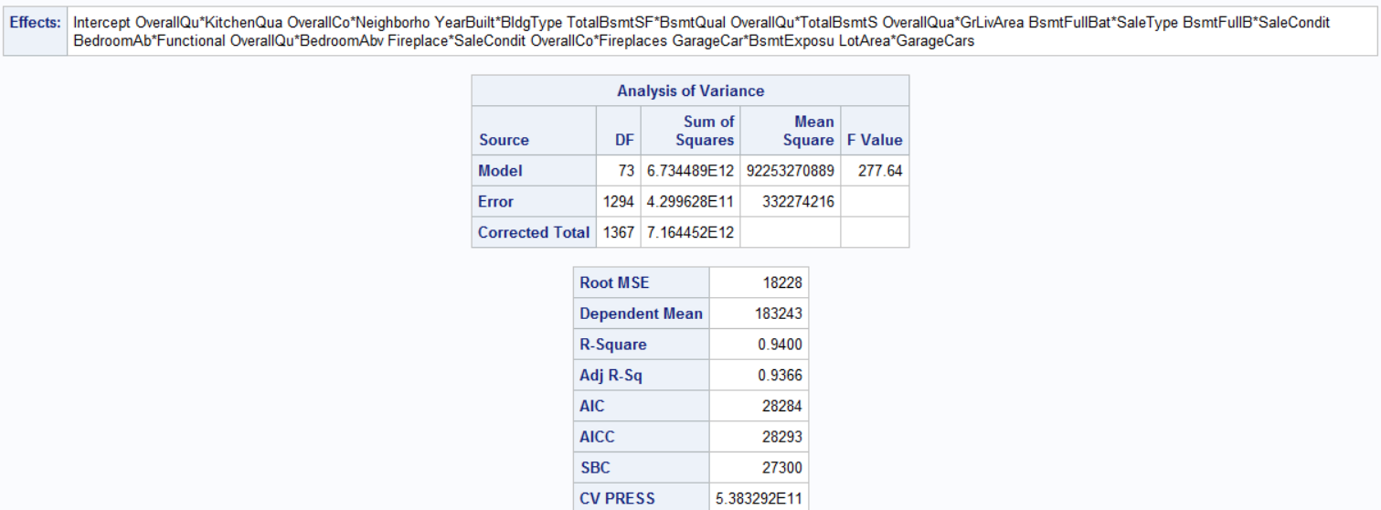

## Backward model using numeric variables derived from forward variable selection could not run because of lack of memory

**Do Variable Selection for cleaned numeric and categorical variables with interactions. Use numeric variables derived from Backwards selection**

## Stepwise model using numeric variables derived from backwards variable selection (Table 2.12)

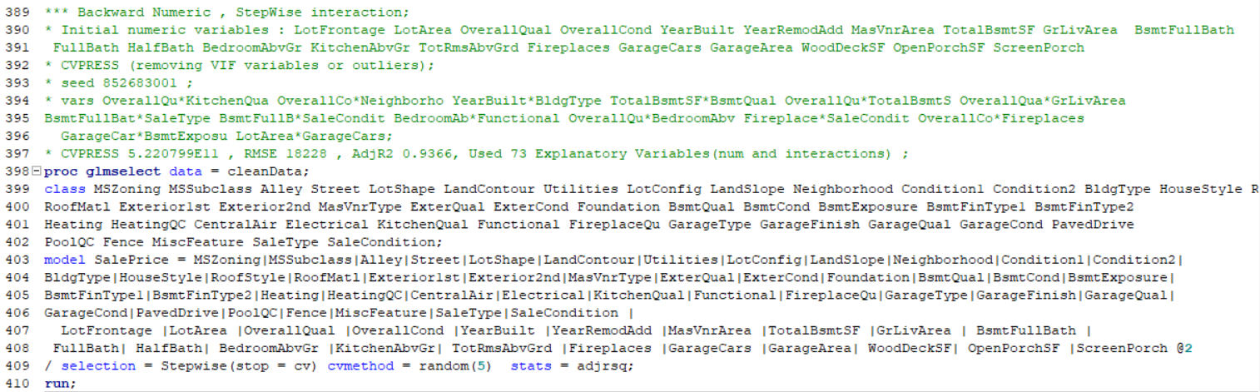

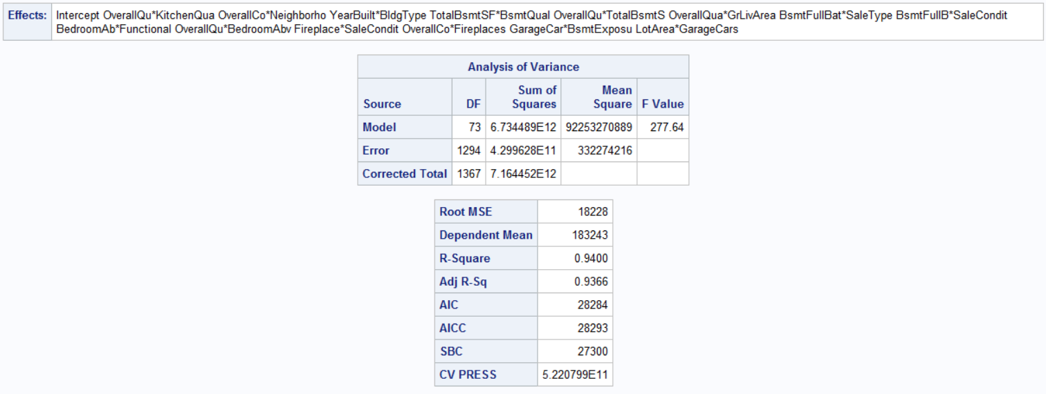

## Forward model using numeric variables derived from backwards variable selection (Table 2.13)

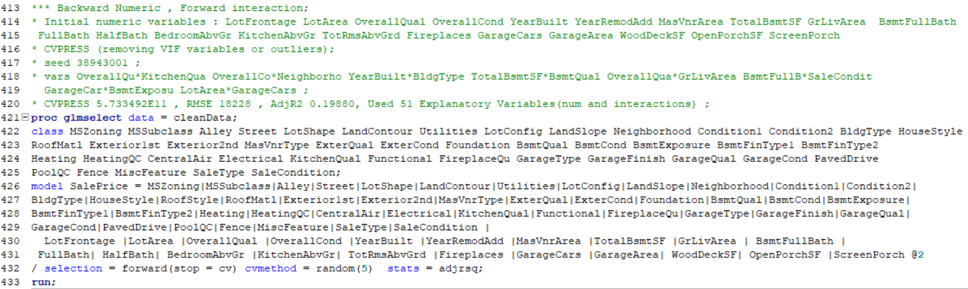

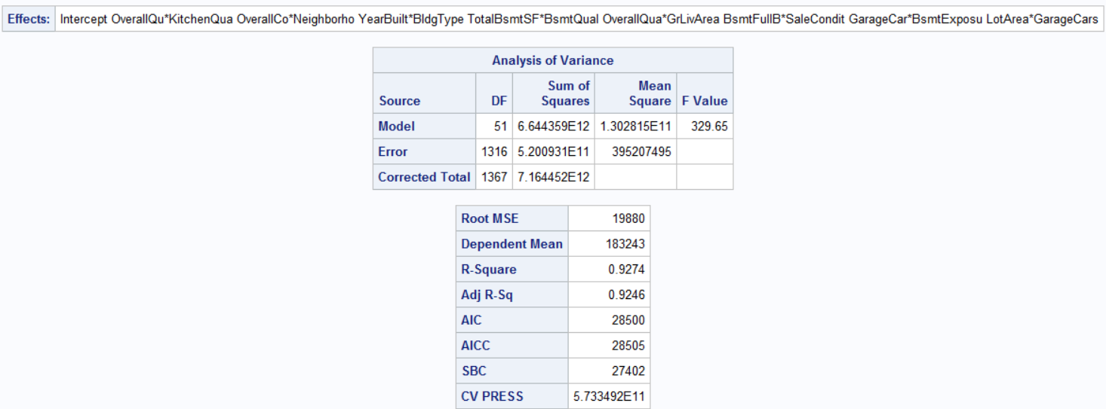

## Backward model using numeric variables derived from backwards variable selection could not run because of lack of memory

**Do Variable Selection for cleaned categorical variables**

## StepWise Selection model for cleaned categorical variables (Table 2.14)

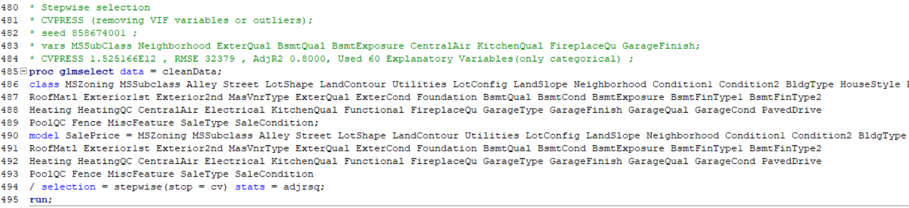

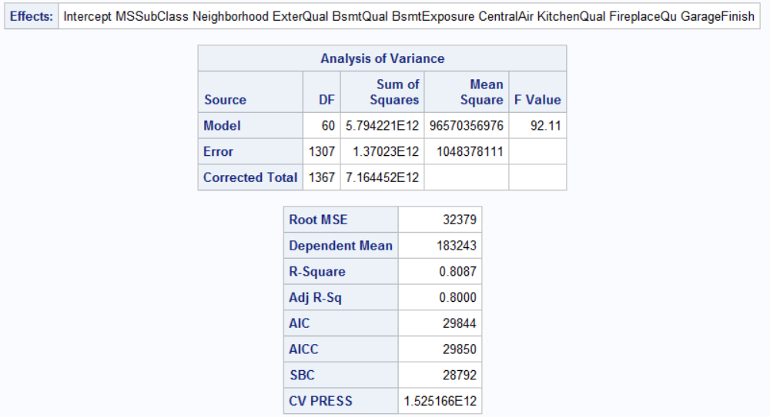

## Forward Selection model for cleaned categorical variables (Table 2.15)

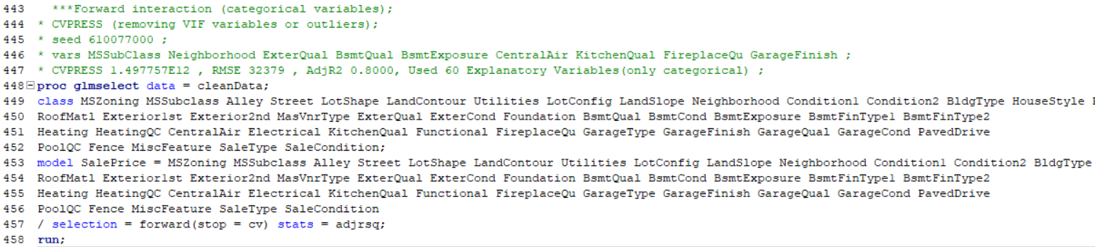

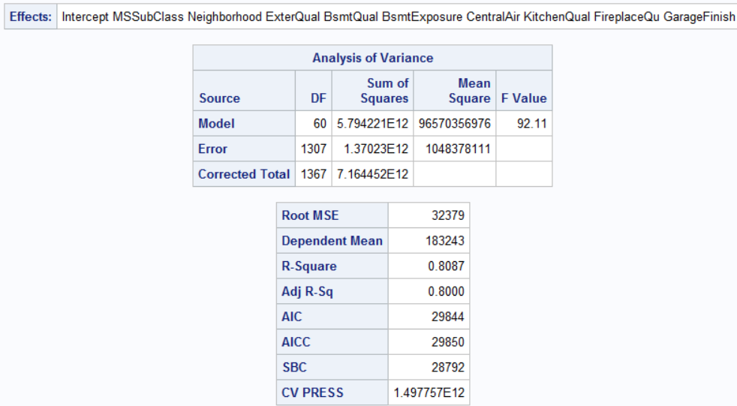

## Backward Selection model for cleaned categorical variables (Table 2.16)

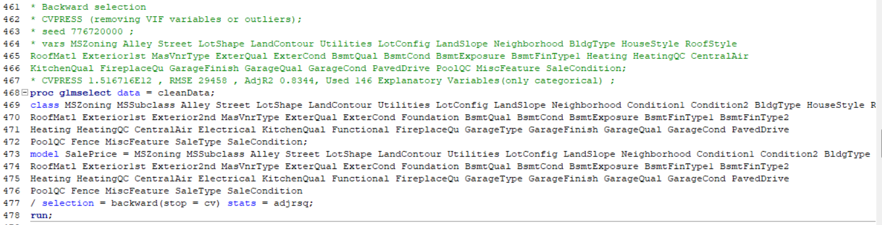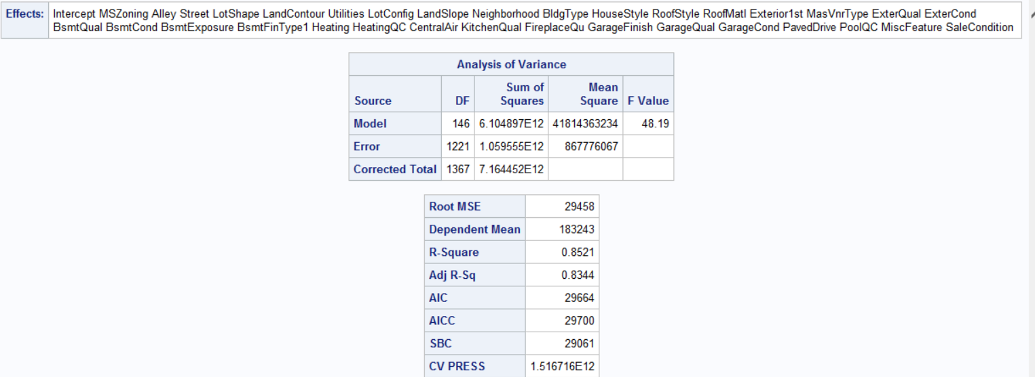

**Do Variable Selection for cleaned numeric and categorical variables with interactions. Use all variables available**

## Tying Stepwise Selection with clean data (Table 2.17)

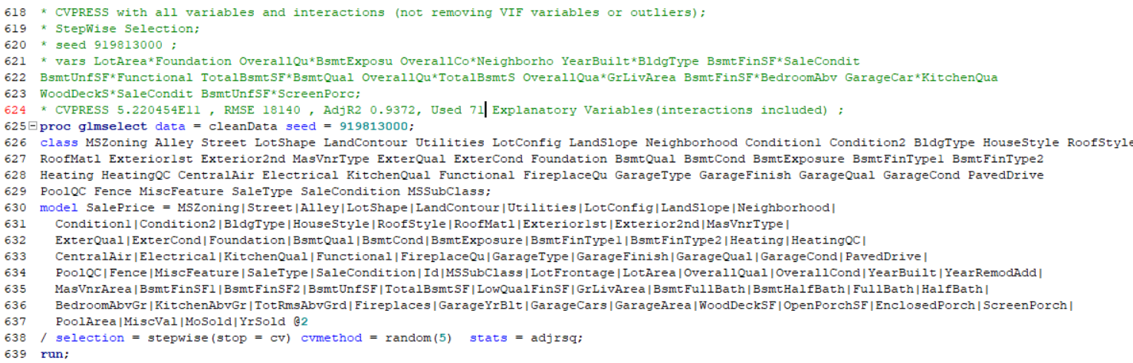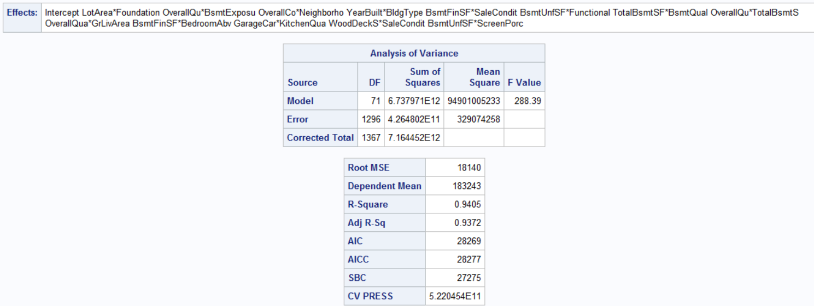

## Tying Forward Selection with clean data (Table 2.18)

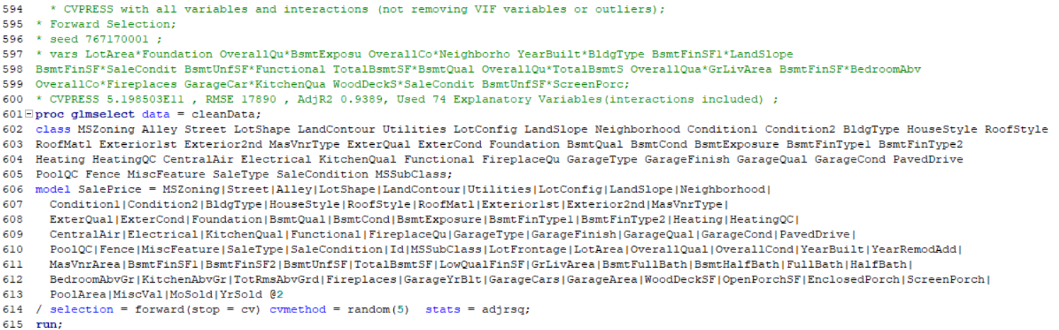

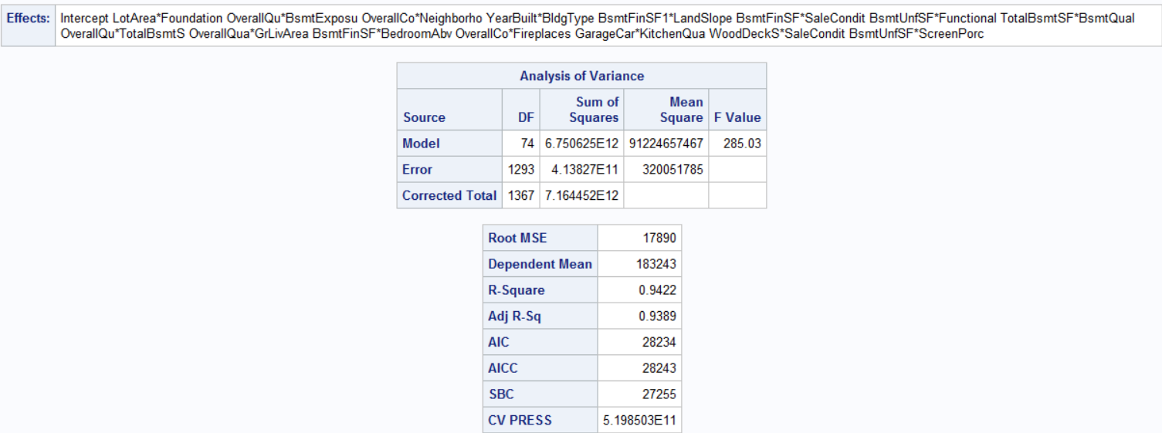

**Use sl to find custom models using best performing variables**

**# Best categorical variables were from forward variable selection of categorical variables (Table 2.15)**

**# Best numeric variables from backward variable selection of numeric variables (Table 2.7)**

## Do stepwise selection using best numeric and categorical variables (Table 2.19)

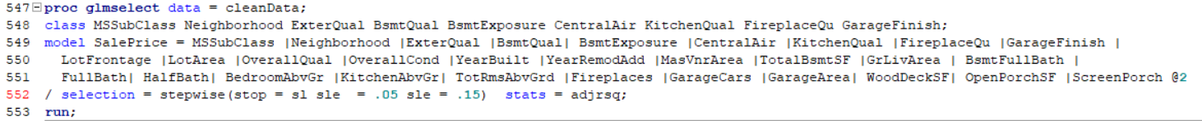

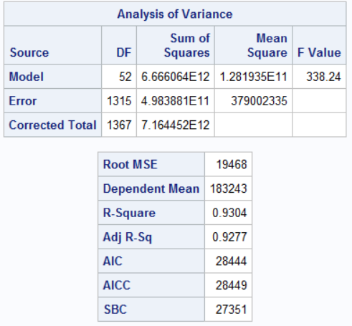

## Do forward selection using best numeric and categorical variables (Table 2.20)

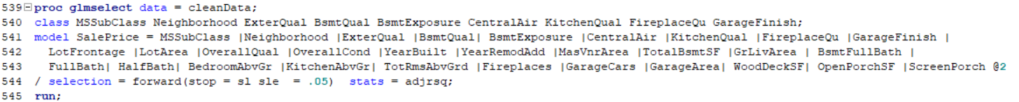

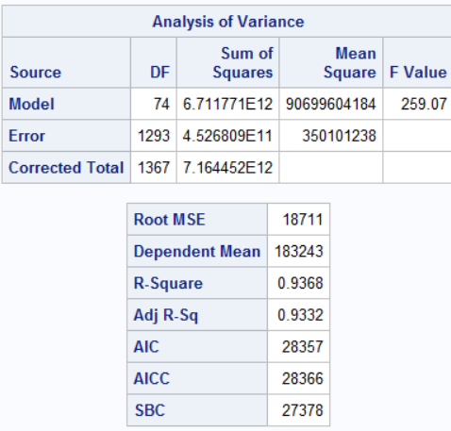

## Do backward selection using best numeric and categorical variables (Table 2.21)

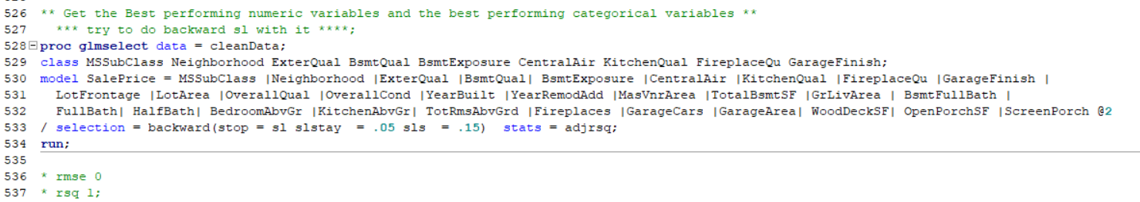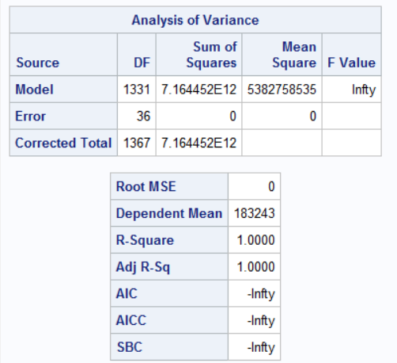

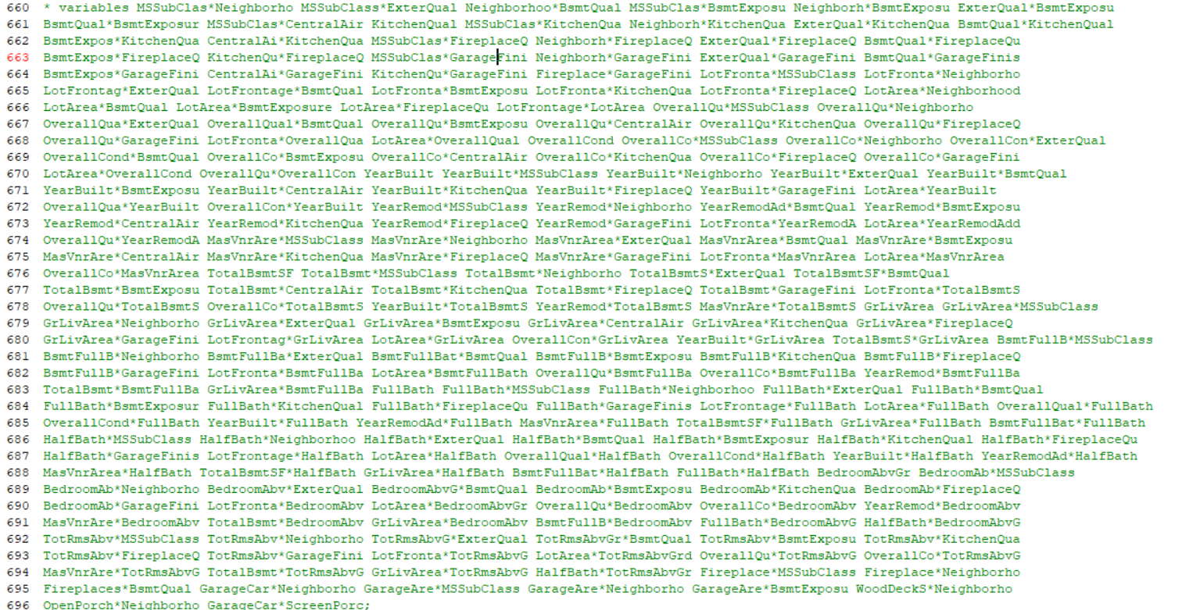

**Finding variables with linear relationship with SalesPrice(Starting at Table 2.21)( Plot 2.10)**

**#Using dataset that had all numeric outliers dealt with. All categorical variables now cleaned from the [Clean Categorical Variables in R section]**

**# Dataset had 81 numerical NAs removed. Two waves of CooksD and RStudent remediation. First round removed 3 observations, second round removed 8 observations.**

# (Plot 2.11)



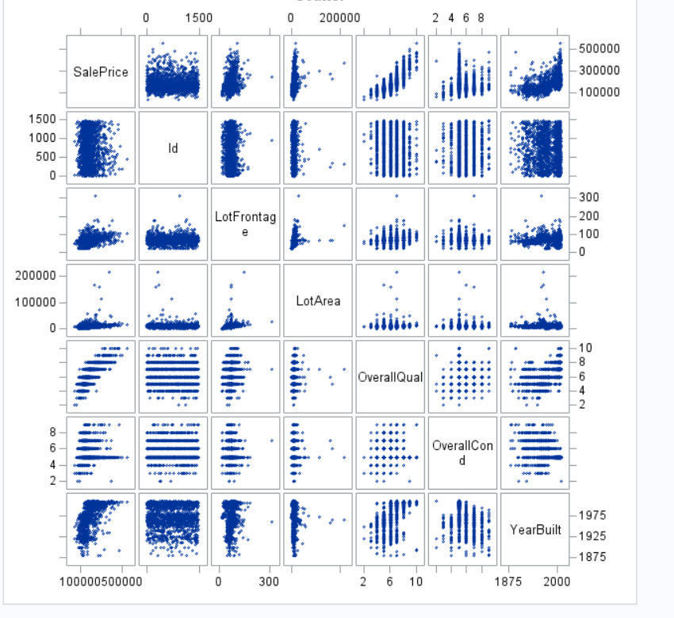

# (Plot 2.12)



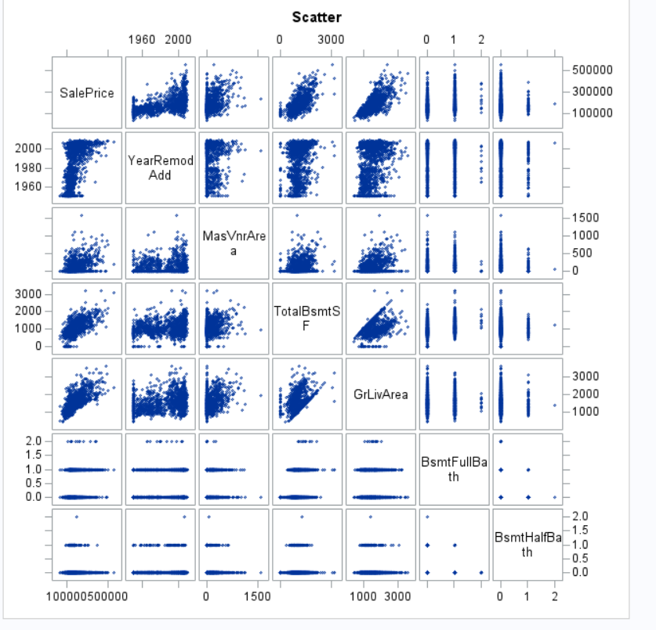

# (Plot 2.13)

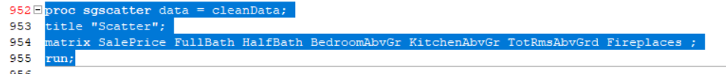

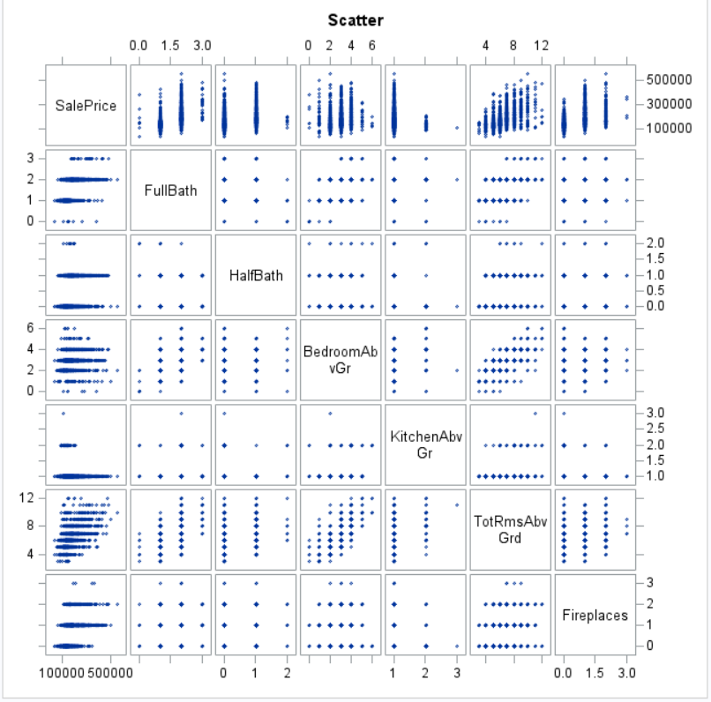

# (Plot 2.14)



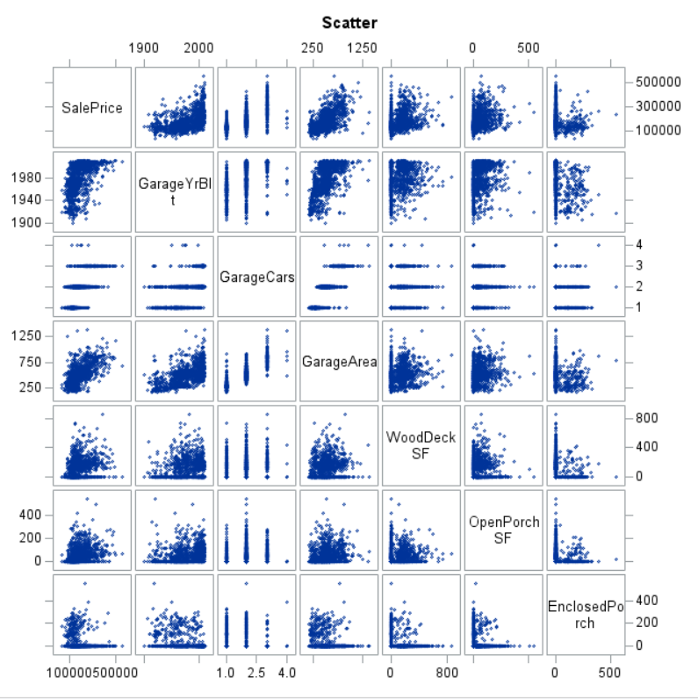

# (Plot 2.15)

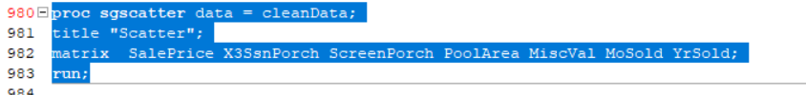

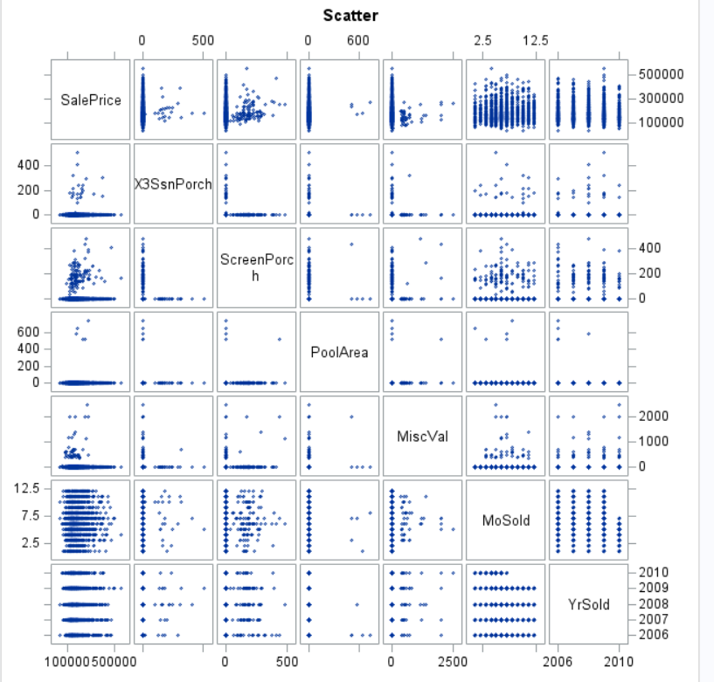

# Only variables that seemed linearly related (Plot 2.16)

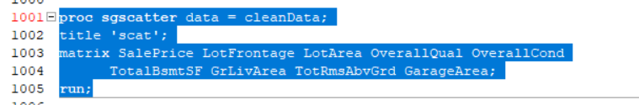

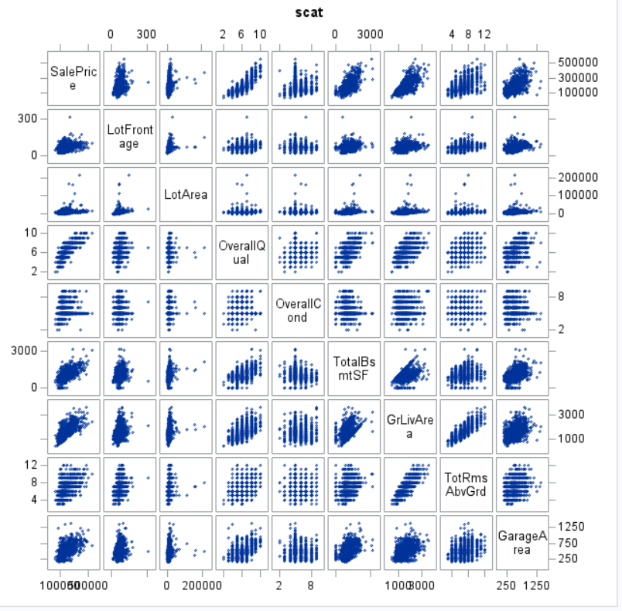

# Check if linearly related variables have high VIF (Plot 2.17)

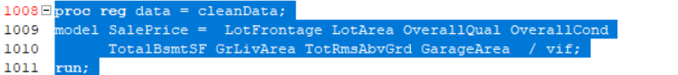

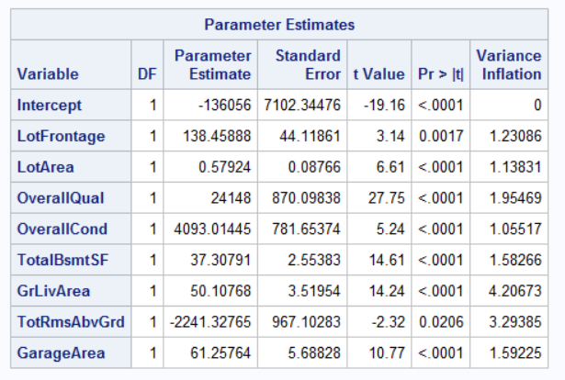

**Start doing variable selection for the models**

**# Backwards variable selection**

# Backwards variable selection for continuous variables (Back Table 2.1)

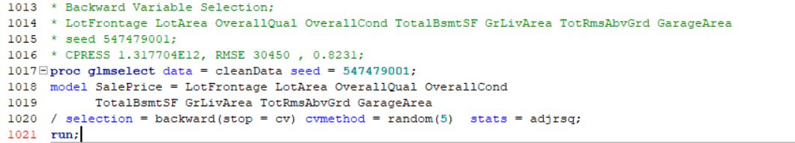

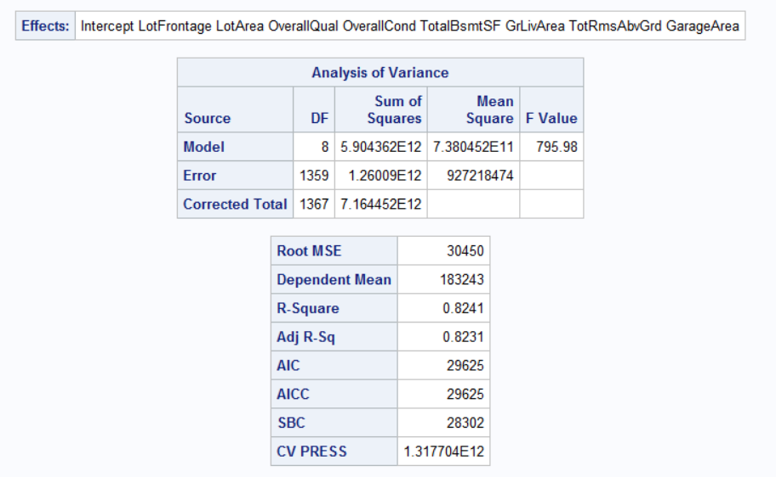

# Residual plot for the back (Back Plot 2.1)

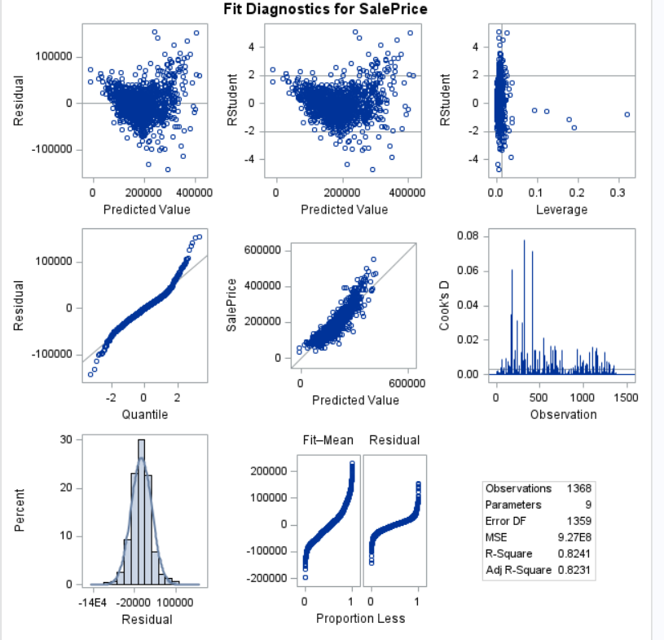

# Residual Plot for numeric variables with linear relationship (Back Plot 2.2)

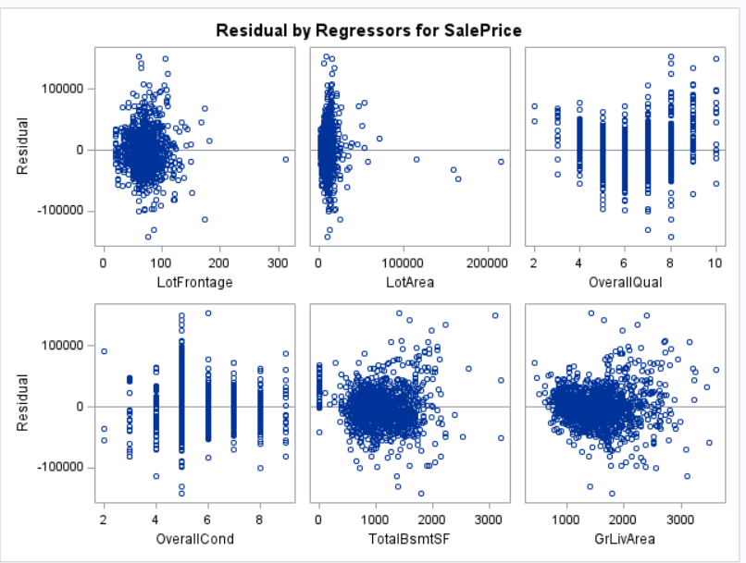

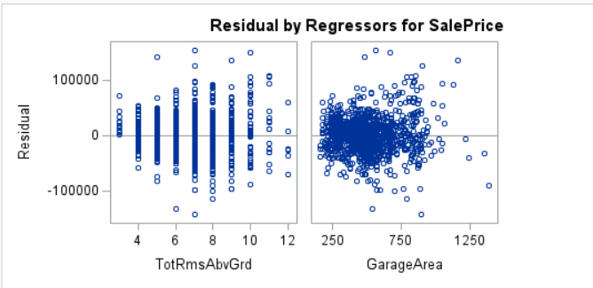

# Residual plots for only variables that looked normal with equal standard deviation (Back Plot 2.3)

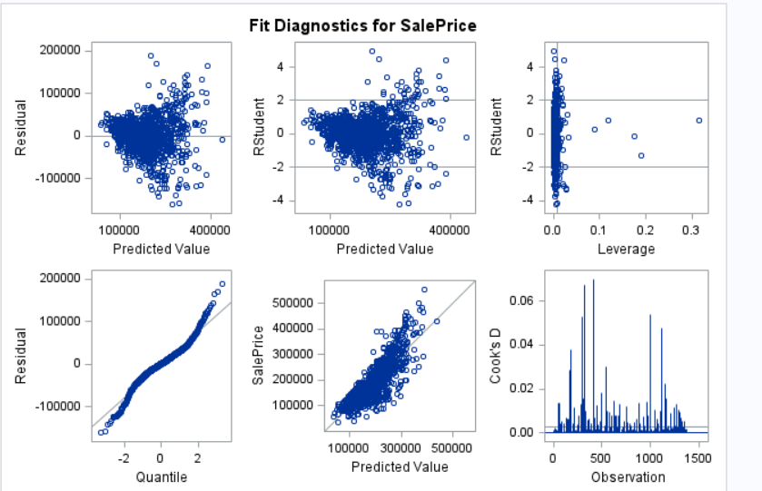

# Removal of observations that had had RStudent higher than |2|

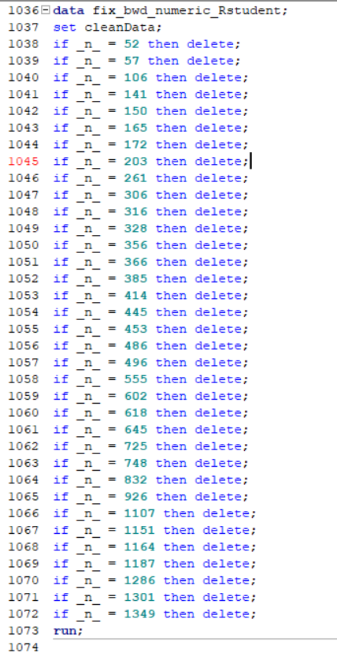

# Residual Plot for final backwards selection model (Back Plot 2.4)

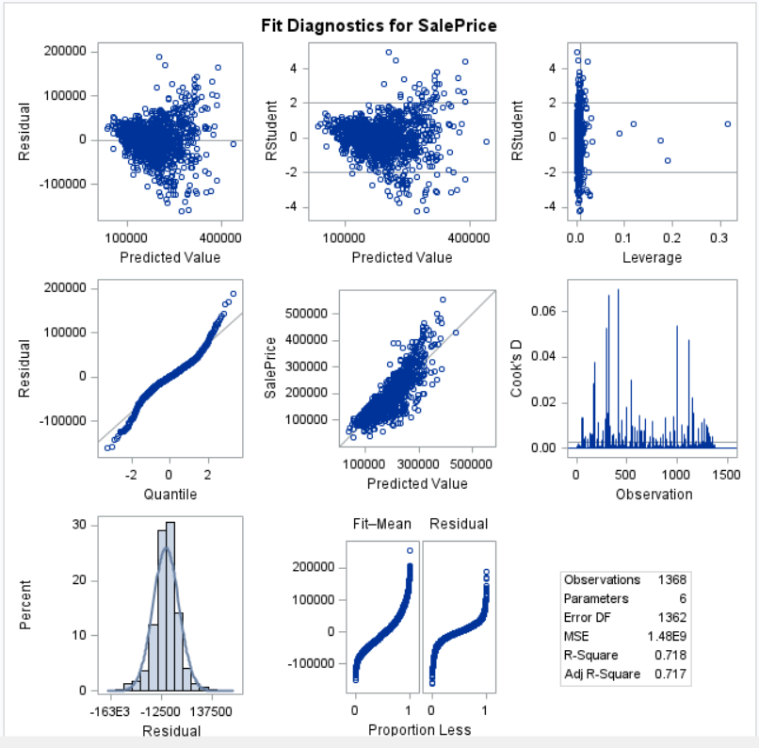

# Residual plot after we removed the Cook’sD of .15 (Back Plot 2.5)

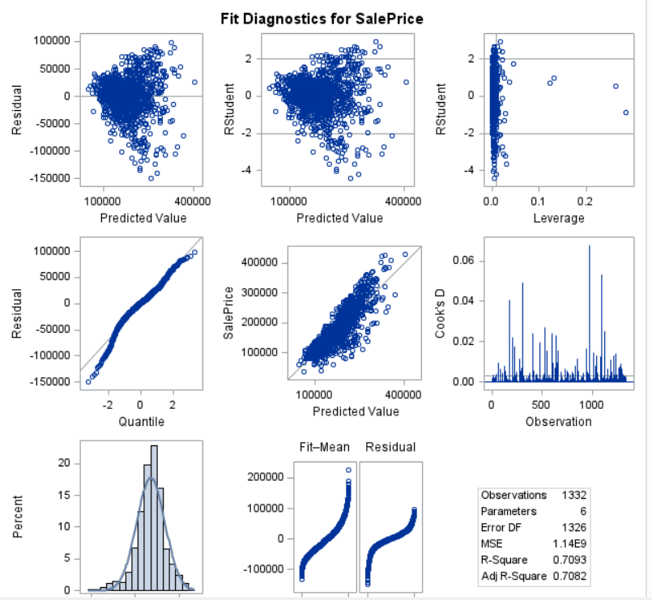

# How did the clean backwards model perform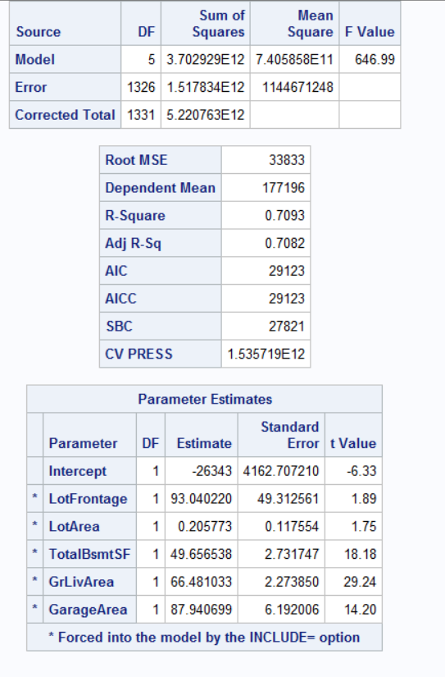

**# Stepwise Variable Selection**

# Use same numeric variables from backwards variable selection dataset after one more removing cooksD of .15 (Stepwise Table 2.1)

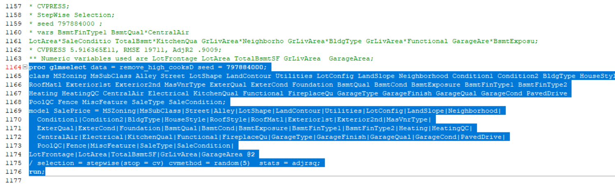

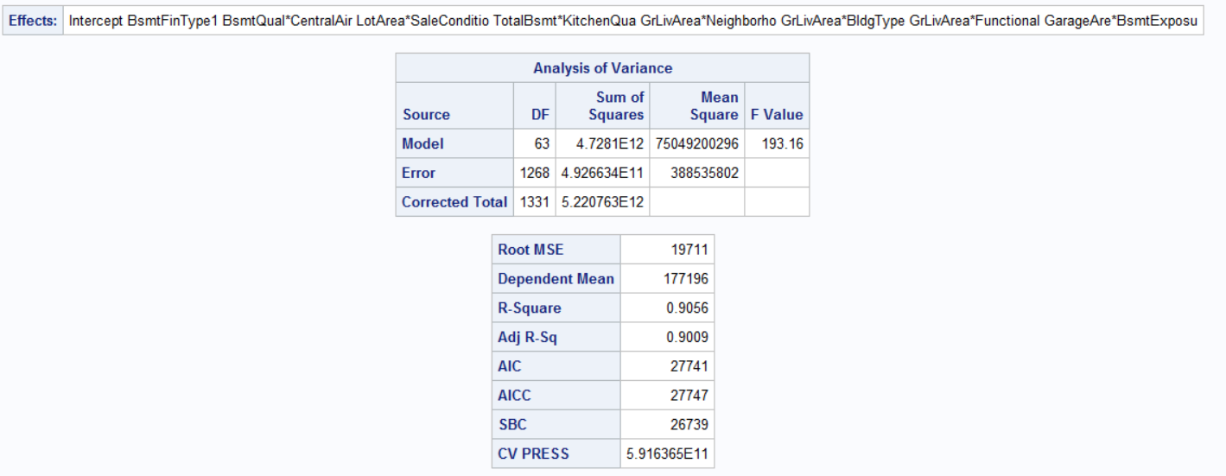

# Residual plots for initial stepwise variable selection model (Stepwise Plot 2.1)

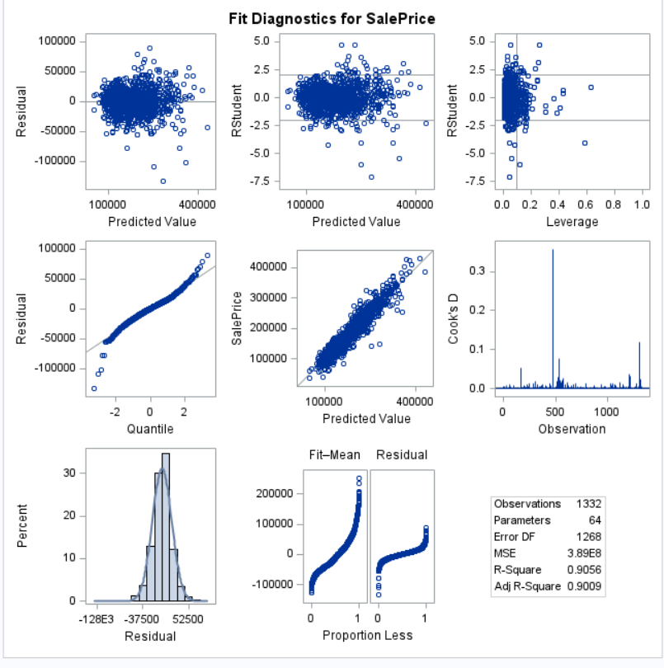

# Residual plots for cleaned stepwise variable selection model (Stepwise Plot 2.2)

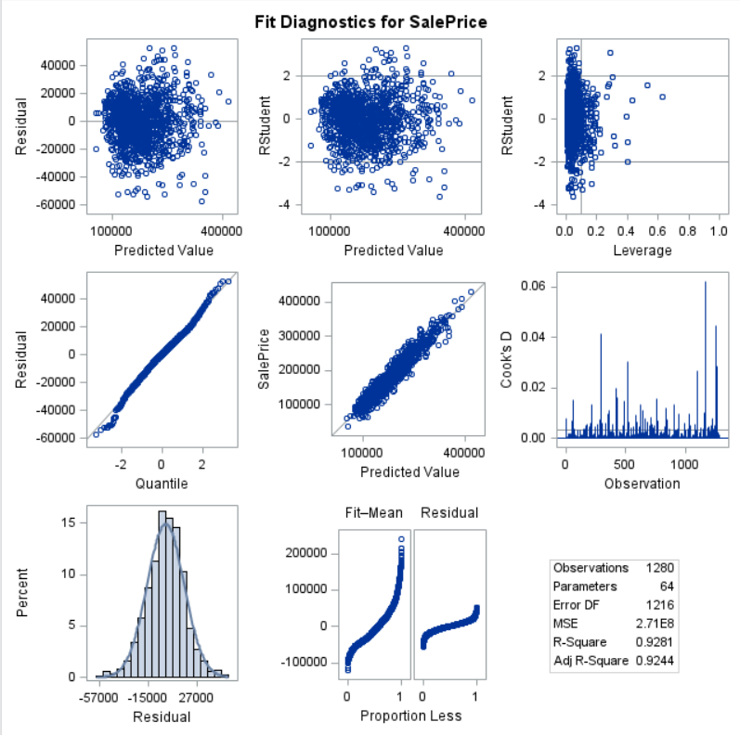

# Stepwise CVPRESS after the influential point remediation (Stepwise Table 2.2)

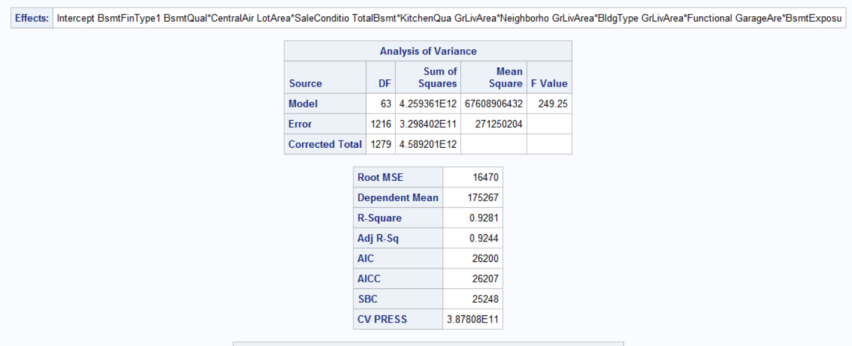

**# Forward Variable Selection**

# Use same initial dataset that the stepwise variable selection used after removing cooksD of .15

# Residual plots for initial forward variable selection model (Forward Plot 2.1)

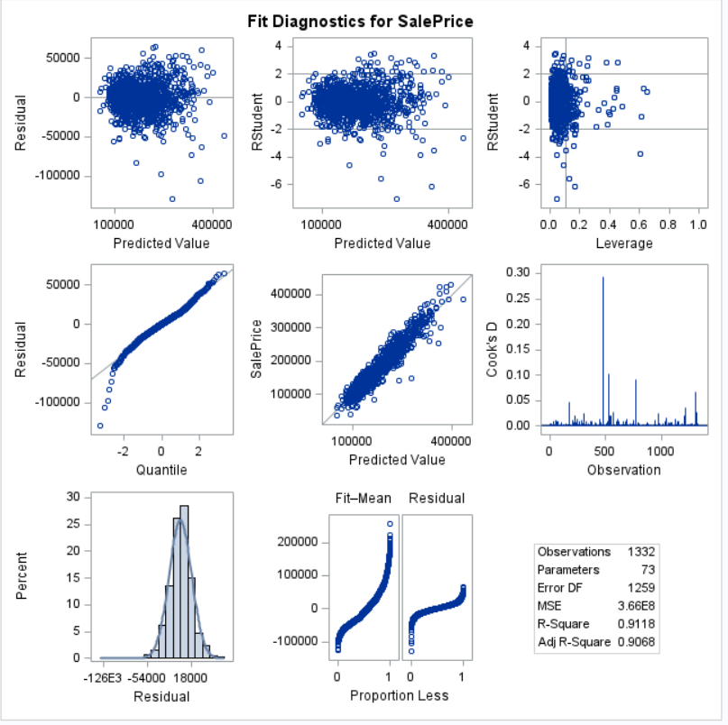

# Residual plots for cleaned forward variable selection model (Forward Plot 2.2)

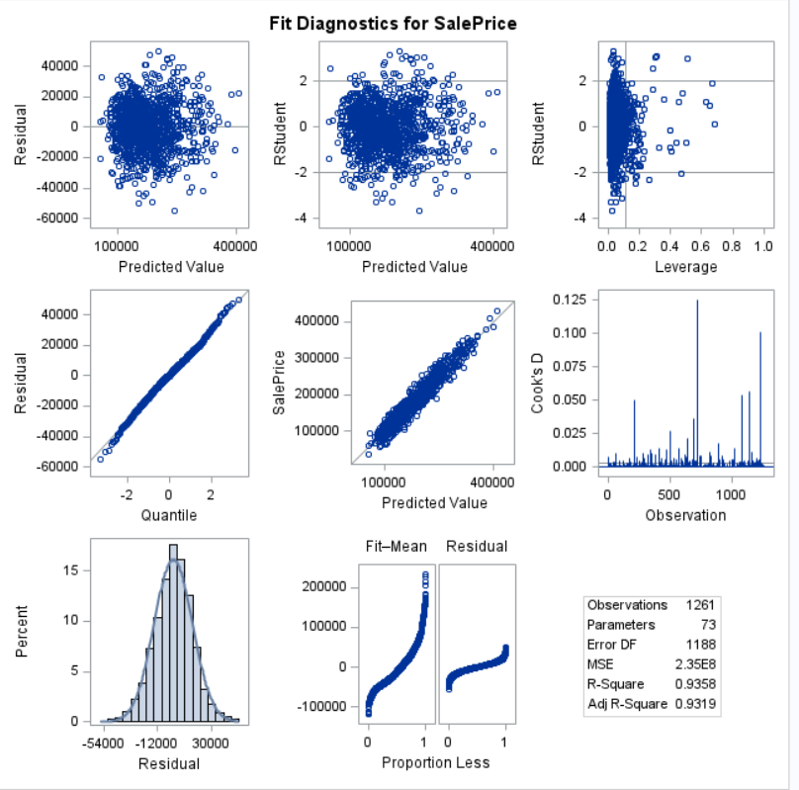

# CVPRESS after two rounds of influential point analysis (Forward Plot 2.1)

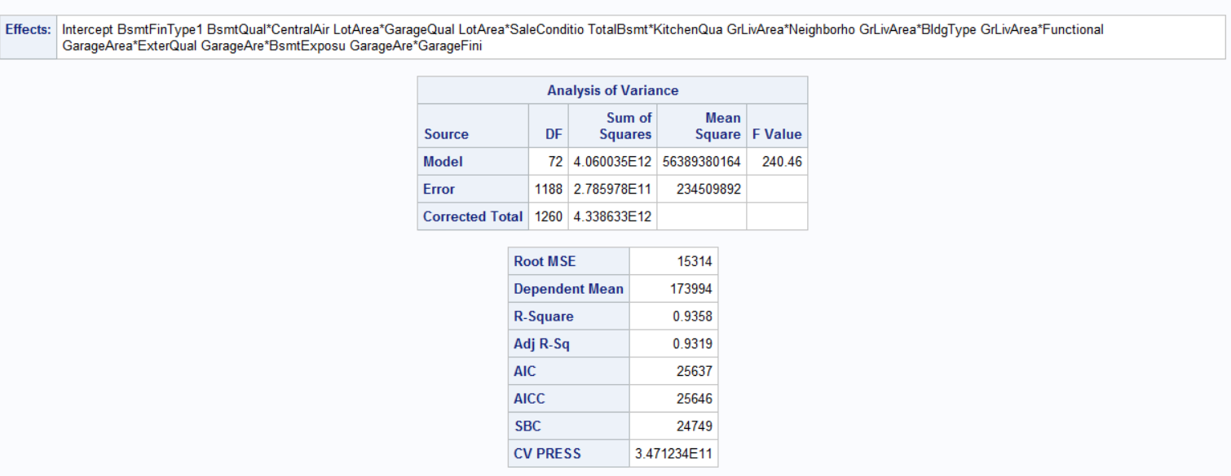

**# Custom model**

**# How does the model perform with CV including all (Custom table 2.1)**

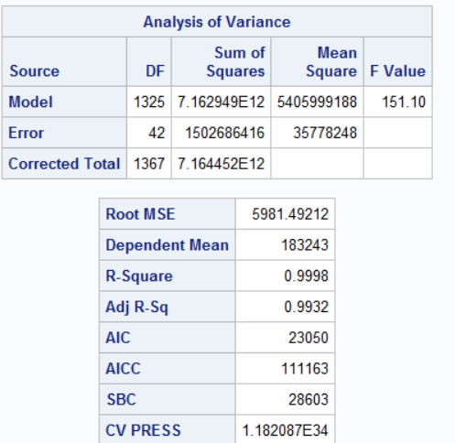

**Code to Verify our Kaggle Scores**

**### Go to** [**garcialuismanuel/Stats-Project: datasets needed to replicate results from stats project (github.com)**](https://github.com/garcialuismanuel/Stats-Project) **and upload the test dataset from there. There were some levels it had that the training datasets didn’t and other issues that were fixed for it.**

**###Name the test dataset test_analysis2**

**### Every model also has their respective train dataset here**

**# Custom Model**

**# Train the Model but set fix_the_categorialNAs to the dataset with stepwise_train_dataset.csv**

**custom_model = lm(SalePrice ~ MSSubClass*Neighborhood+MSSubClass*ExterQual+Neighborhood*BsmtQual+**

**MSSubClass*BsmtExposure+Neighborhood*BsmtExposure+ExterQual*BsmtExposure+**

**BsmtQual*BsmtExposure+MSSubClass*CentralAir+KitchenQual+MSSubClass*KitchenQual+**

**Neighborhood*KitchenQual+ExterQual*KitchenQual+BsmtQual*KitchenQual+BsmtExposure*KitchenQual+**

**CentralAir*KitchenQual+MSSubClass*FireplaceQu+Neighborhood*FireplaceQu+ExterQual*FireplaceQu+**

**BsmtQual*FireplaceQu++BsmtExposure*FireplaceQu+KitchenQual*FireplaceQu+MSSubClass*GarageFinish+**

**Neighborhood*GarageFinish+ExterQual*GarageFinish+BsmtQual*GarageFinish++BsmtExposure*GarageFinish+**

**CentralAir*GarageFinish+KitchenQual*GarageFinish+FireplaceQu*GarageFinish+LotFrontage*MSSubClass+**

**LotFrontage*Neighborhood++LotFrontage*ExterQual+LotFrontage*BsmtQual+LotFrontage*BsmtExposure+LotFrontage*KitchenQual+**

**LotFrontage*FireplaceQu+LotArea*Neighborhood++LotArea*BsmtQual+LotArea*BsmtExposure+LotArea*FireplaceQu+**

**LotFrontage*LotArea+OverallQual*MSSubClass+OverallQual*Neighborhood++OverallQual*ExterQual+OverallQual*BsmtQual+**

**OverallQual*BsmtExposure+OverallQual*CentralAir+OverallQual*KitchenQual+OverallQual*FireplaceQu++OverallQual*GarageFinish+**

**LotFrontage*OverallQual+LotArea*OverallQual+OverallCond+OverallCond*MSSubClass+OverallCond*Neighborhood+**

**OverallCond*ExterQual+OverallCond*BsmtQual+OverallCond*BsmtExposure+OverallCond*CentralAir+OverallCond*KitchenQual+**

**OverallCond*FireplaceQu+OverallCond*GarageFinish++LotArea*OverallCond+OverallQual*OverallCond+YearBuilt+**

**YearBuilt*MSSubClass+YearBuilt*Neighborhood+YearBuilt*ExterQual+YearBuilt*BsmtQual++YearBuilt*BsmtExposure+**

**YearBuilt*CentralAir+YearBuilt*KitchenQual+YearBuilt*FireplaceQu+YearBuilt*GarageFinish+LotArea*YearBuilt+**

**OverallQual*YearBuilt+OverallCond*YearBuilt+YearRemodAdd*MSSubClass+YearRemodAdd*Neighborhood+YearRemodAdd*BsmtQual+**

**YearRemodAdd*BsmtExposure++YearRemodAdd*CentralAir+YearRemodAdd*KitchenQual+YearRemodAdd*FireplaceQu+**

**YearRemodAdd*GarageFinish+LotFrontage*YearRemodAdd+LotArea*YearRemodAdd++OverallQual*YearRemodAdd+**

**MasVnrArea*MSSubClass+MasVnrArea*Neighborhood+MasVnrArea*ExterQual+MasVnrArea*BsmtQual+MasVnrArea*BsmtExposure+**

**MasVnrArea*CentralAir+MasVnrArea*KitchenQual+MasVnrArea*FireplaceQu+MasVnrArea*GarageFinish+LotFrontage*MasVnrArea+**

**LotArea*MasVnrArea++OverallCond*MasVnrArea+TotalBsmtSF+TotalBsmtSF*MSSubClass+TotalBsmtSF*Neighborhood+**

**TotalBsmtSF*ExterQual+TotalBsmtSF*BsmtQual++TotalBsmtSF*BsmtExposure+TotalBsmtSF*CentralAir+TotalBsmtSF*KitchenQual+**

**TotalBsmtSF*FireplaceQu+TotalBsmtSF*GarageFinish+LotFrontage*TotalBsmtSF++OverallQual*TotalBsmtSF+OverallCond*TotalBsmtSF+**

**YearBuilt*TotalBsmtSF+YearRemodAdd*TotalBsmtSF+MasVnrArea*TotalBsmtSF+GrLivArea+GrLivArea*MSSubClass++GrLivArea*Neighborhood+**

**GrLivArea*ExterQual+GrLivArea*BsmtExposure+GrLivArea*CentralAir+GrLivArea*KitchenQual+GrLivArea*FireplaceQu+**

**GrLivArea*GarageFinish+LotFrontage*GrLivArea+LotArea*GrLivArea+OverallCond*GrLivArea+YearBuilt*GrLivArea+**

**TotalBsmtSF*GrLivArea+BsmtFullBath*MSSubClass+BsmtFullBath*Neighborhood+BsmtFullBath*ExterQual+BsmtFullBath*BsmtQual+**

**BsmtFullBath*BsmtExposure+BsmtFullBath*KitchenQual+BsmtFullBath*FireplaceQu++BsmtFullBath*GarageFinish+**

**LotFrontage*BsmtFullBath+LotArea*BsmtFullBath+OverallQual*BsmtFullBath+OverallCond*BsmtFullBath+YearRemodAdd*BsmtFullBath+**

**TotalBsmtSF*BsmtFullBath+GrLivArea*BsmtFullBath+FullBath+FullBath*MSSubClass+FullBath*Neighborhood+FullBath*ExterQual+**

**FullBath*BsmtQual+FullBath*BsmtExposure+FullBath*KitchenQual+FullBath*FireplaceQu+FullBath*GarageFinish+**

**LotFrontage*FullBath+LotArea*FullBath+OverallQual*FullBath++OverallCond*FullBath+YearBuilt*FullBath+YearRemodAdd*FullBath+**

**MasVnrArea*FullBath+TotalBsmtSF*FullBath+GrLivArea*FullBath+BsmtFullBath*FullBath++HalfBath*MSSubClass+HalfBath*Neighborhood+**

**HalfBath*ExterQual+HalfBath*BsmtQual+HalfBath*BsmtExposure+HalfBath*KitchenQual+HalfBath*FireplaceQu++HalfBath*GarageFinish+**

**LotFrontage*HalfBath+LotArea*HalfBath+OverallQual*HalfBath+OverallCond*HalfBath+YearBuilt*HalfBath+YearRemodAdd*HalfBath+**

**MasVnrArea*HalfBath+TotalBsmtSF*HalfBath+GrLivArea*HalfBath+BsmtFullBath*HalfBath+FullBath*HalfBath+BedroomAbvGr+**

**BedroomAbvGr*MSSubClass+BedroomAbvGr*Neighborhood+BedroomAbvGr*ExterQual+BedroomAbvGr*BsmtQual+BedroomAbvGr*BsmtExposure+**

**BedroomAbvGr*KitchenQual+BedroomAbvGr*FireplaceQu++BedroomAbvGr*GarageFinish+LotFrontage*BedroomAbvGr+LotArea*BedroomAbvGr+**

**OverallQual*BedroomAbvGr+OverallCond*BedroomAbvGr+YearRemodAdd*BedroomAbvGr++MasVnrArea*BedroomAbvGr+TotalBsmtSF*BedroomAbvGr+**

**GrLivArea*BedroomAbvGr+BsmtFullBath*BedroomAbvGr+FullBath*BedroomAbvGr+HalfBath*BedroomAbvGr++TotRmsAbvGrd*MSSubClass+**

**TotRmsAbvGrd*Neighborhood+TotRmsAbvGrd*ExterQual+TotRmsAbvGrd*BsmtQual+TotRmsAbvGrd*BsmtExposure+TotRmsAbvGrd*KitchenQual+**

**TotRmsAbvGrd*FireplaceQu+TotRmsAbvGrd*GarageFinish+LotFrontage*TotRmsAbvGrd+LotArea*TotRmsAbvGrd+OverallQual*TotRmsAbvGrd+**

**OverallCond*TotRmsAbvGrd++MasVnrArea*TotRmsAbvGrd+TotalBsmtSF*TotRmsAbvGrd+GrLivArea*TotRmsAbvGrd+HalfBath*TotRmsAbvGrd+**

**FireplaceQu*MSSubClass+FireplaceQu*Neighborhood++Fireplaces*BsmtQual+GarageCars*Neighborhood+GarageArea*MSSubClass+**

**GarageArea*Neighborhood+GarageArea*BsmtExposure+WoodDeckSF*Neighborhood++OpenPorchSF*Neighborhood+GarageCars*ScreenPorch,**

**data = fix_the_categorialNAs)**

**# Use the model to predict SalePrice**

**predictions_custom = predict(custom_model, test_analysis2)**

**custom_submission = data.frame(Id = test_analysis2$Id, SalePrice = predictions_custom)**

**# Backwards Model**

**# Train the Model but set fix_the_categorialNAs to the dataset with backward_train_dataset.csv**

**backward_model = lm(SalePrice ~ LotFrontage + LotArea + TotalBsmtSF + GrLivArea + GarageArea, data = SAS_remove_high_cooksD)**

**# Use model to predict SalePrice**

**predictions_backward = predict(backward_model, test_analysis2)**

**backward_submission = data.frame(Id = test_analysis2$Id, SalePrice = predictions_backward)**

**# Forwards Model**

**# Train the Model but set forward_fix_RStud_Final to the dataset with forward_train_dataset.csv**

**final_forward_model_makePredictions = lm(SalePrice ~BsmtFinType1+BsmtQual*CentralAir+LotArea*GarageQual+LotArea*SaleCondition+**

**TotalBsmtSF*KitchenQual+GrLivArea*Neighborhood+GrLivArea*BldgType+GrLivArea*Functional+**

**GarageArea*ExterQual+GarageArea*BsmtExposure+GarageArea*GarageFinish,**

**data = forward_fix_RStud_Final)**

**write.csv(forward_fix_RStud_Final, 'forward_train_dataset.csv')**

**# Use model to predict SalePrice**

**predictions_forward = predict(final_forward_model_makePredictions , test_analysis2)**

**forward_submission = data.frame(Id = test_analysis2$Id, SalePrice = predictions_forward)**

**# Stepwise Model**

**# Train the Model but set stepwise_fix_RStud_Final to the dataset with stepwise_train_dataset.csv**

**final_stepwise_model_makePredictions = lm(SalePrice ~ BsmtFinType1+BsmtQual*CentralAir+LotArea*SaleCondition+TotalBsmtSF*KitchenQual+**

**GrLivArea*Neighborhood+GrLivArea*BldgType+GrLivArea*Functional+GarageArea*BsmtExposure,**

**data = stepwise_fix_RStud_Final)**

**# Use the model to predict SalePrice**

**predictions_stepwise= predict(final_stepwise_model_makePredictions , test_analysis2)**

**stepwise_submission = data.frame(Id = test_analysis2$Id, SalePrice = predictions_stepwise)**